**Workforce Administration Solution (Dev)**

College Name: Angel College of Engineering and Technology

College code : 7103

Department : Computer Science and Engineering

### NM Project : Workforce Administration Solution (Dev)

**Group project**

**TEAM ID: NM2024TMID03360**

* Bernet Anto .M : NMID- **5CC493BED199A799EB0404F638BDE323**
* Anandharaj. R : NMID- **0C2848D8B1FB351B6E64BDEA12E4FF68**
* Anitha .C : NMID- **A67A117E03216B9B4524EF6B6BD153AD**
* Arun Kumar .M : NMID- **9557DA0DBC28B7C9FEC49B23A96330FD**

**Project Description**

Workforce Administration Solution is a software application or platform designed to streamline and automate various aspects of employee’s working on projects and Asset Assignment processes within an organization. It serves as a centralized system for managing employee data, number of projects an employee is working on, tracking employee performance, and keeping record for the assets which they are assigned to.

**Abstract**

The Workforce Administration Solution (Dev) is a comprehensive, scalable platform designed to streamline and automate the management of workforce-related processes within organizations. This solution aims to enhance operational efficiency by integrating key functionalities such as employee onboarding, time and attendance tracking, payroll management, performance reviews, and compliance monitoring. Developed with modern technologies, it supports seamless collaboration across HR, payroll, and operational teams while ensuring data accuracy and compliance with labor laws and company policies. The solution features intuitive user interfaces, real-time analytics, and configurable workflows that enable HR professionals to manage complex workforce tasks with ease. Additionally, the system supports integration with existing enterprise resource planning (ERP) tools, providing a centralized view of workforce data and helping organizations optimize labor costs, reduce administrative overhead, and improve employee experience. With a focus on scalability and flexibility, the Workforce Administration Solution (Dev) is designed to meet the evolving needs of businesses of all sizes and industries.

**Key Benefits**

**1. Unified Platform for HR and Business Operations**

* Centralized Data
* Cross-Departmental Collaboration

**2. Customizable Workforce Management**

* Tailored to Your Needs
* Custom Objects and Fields

**3. Enhanced Reporting and Analytics**

* Real-Time Dashboards
* Advanced Analytics (Einstein Analytics

**4. Seamless Integration with Other Systems**

* Third-Party Integrations
* API and Middleware Integration

**5. Automation of HR and Workforce Processes**

* Process Automation (Flow and Process Builder
* Automated Alerts and Notifications

**6. Improved Employee Experience through Self-Service**

* Self-Service Portals
* Mobile Access

**7. Better Compliance and Security**

* Compliance Tracking
* Security and Privacy

**8. Scalability for Growing Organizations**

* Seamless Scaling
* Global Workforce Support

**9. Integration with Salesforce Ecosystem (CRM and Sales)**

* Holistic View of Employees and Customers
* Salesforce Chatter for Collaboration

**10. Streamlined Talent Management**

* Recruitment and On boarding
* Performance Management

**11. Real-Time Shift Scheduling and Attendance**

* Scheduling and Availability Management
* Absence and Leave Management

**12. Fostering Employee Engagement and Well-Being**

* Employee Surveys and Feedback
* Wellness Programs and Benefits Tracking

**13. Advanced Security and Permissions**

* Role-Based Access
* Audit Trails and Monitoring

**SALESFORCE**

**Creating developer account**

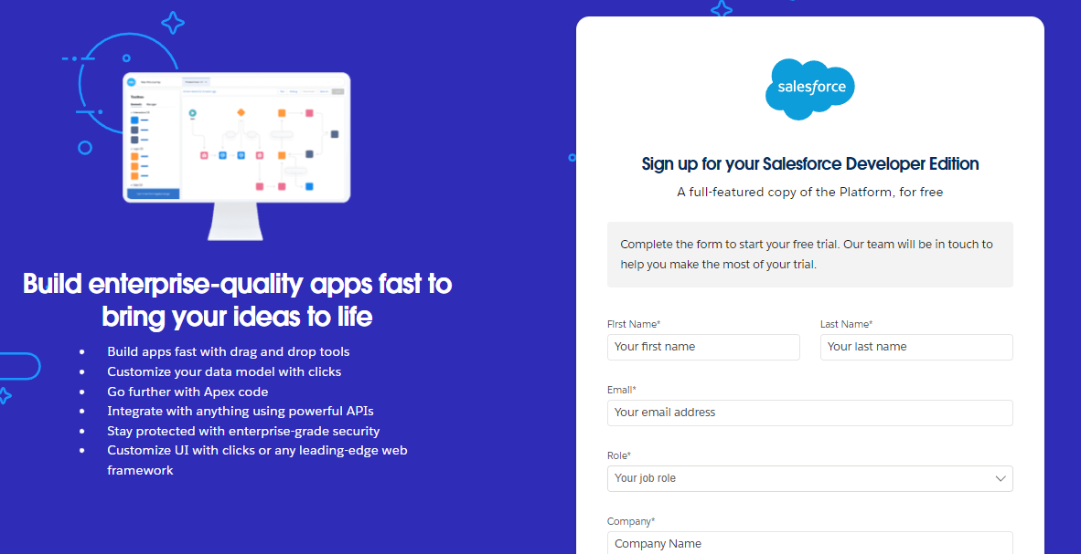

1. First name & Last name
2. Email
3. Role: Developer
4. Company: College Name
5. County: India
6. Postal Code: pin code
7. Username: should be a combination of your name and company

This need not be an actual email id you can give anything in the format: lusername@organization.com

Click on sign me up after filling these.

**Account Activation**

1. Go to the inbox of the email that you used while signing up. Click on the verify account to activate your account. The email may take 5-10mins.

1. Click on Verify Account
2. Give a password and answer a security question and click on change password.
3. Then you will redirect to your salesforce setup page.

This need not be an actual email id you can give anything in the format: username@organization.com

Click on sign me up after filling these.

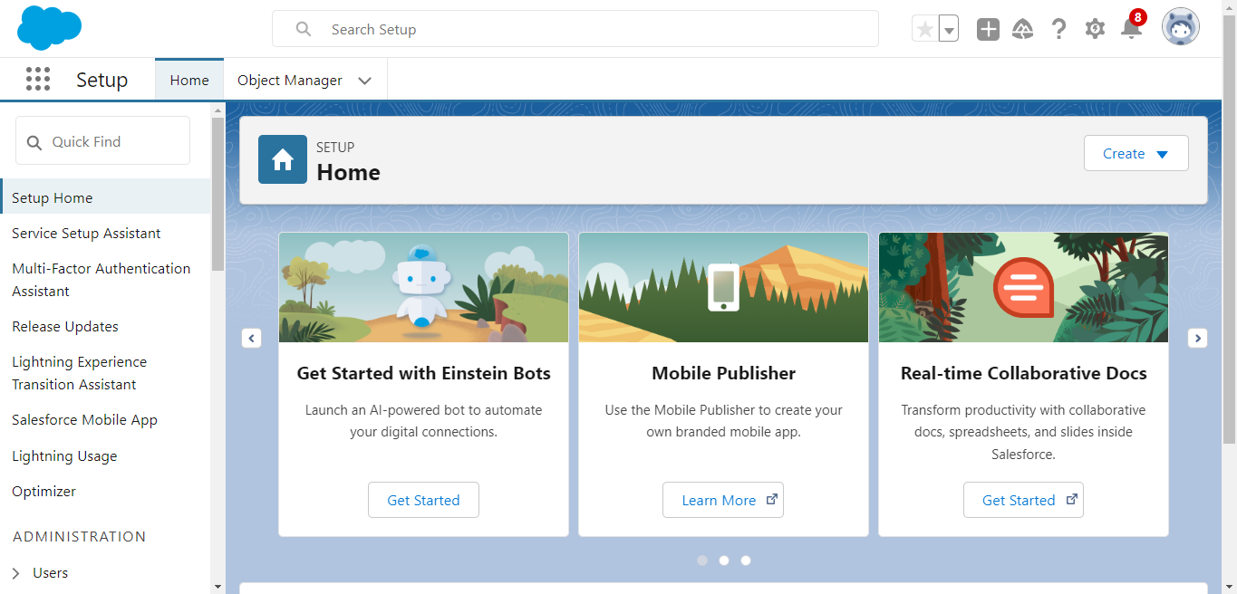

**Create Employee Object**

From the setup page **-->** Click on Object Manager **-->** Click on Create **-->** Click on Custom Object.

1. Enter the label name: Employee.
2. Plural label name: Employees.

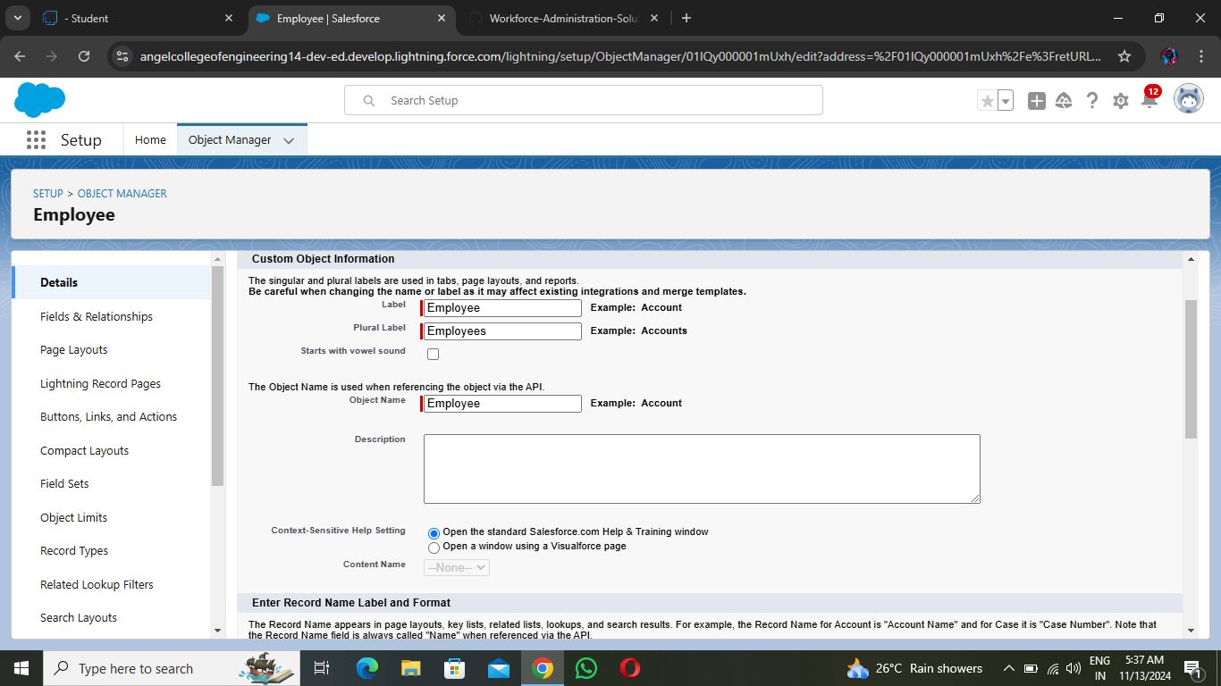

**Enter Record Name Label and Format**

1. Record Name: Employee ID
2. Data Type: Auto Number
3. Display Format: EMS- {0000}
4. Starting Number: 1

Click on Allow reports.

Allow search --> Save.

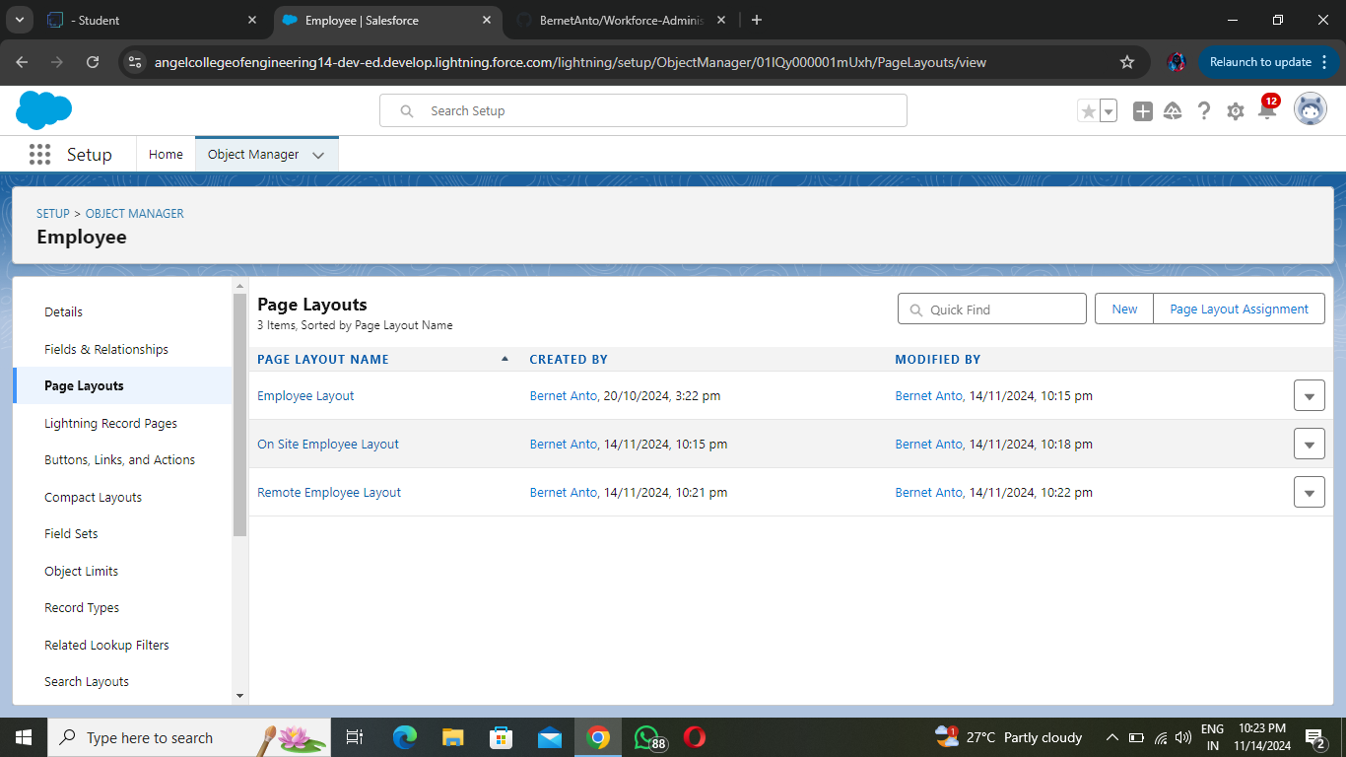

**Create Project Object**

1.     From the setup page --> Click on Object Manager --> Click on Create --> Click on Custom Object.

1)    Enter the label name--> Project

2)    Plural label name--> Projects

3)    Enter Record Name Label and Format

1      Record Name: Project ID

2      Data Type: Auto Number

3      Display Format: Proj- {0000}

4      Starting Number: 1

2.     Click on Allow reports,

3.     Allow search --> Save

**Create 3 more objects with label names as Project Task, Asset, Asset Service.**

**Creating a Custom Tab (Employee)**

1. Go to setup page **-->** type Tabs in Quick Find bar **-->** click on tabs **-->** New (under custom object tab)
2. Select Object (Employee) **-->** Select any tab style **-->** Next (Add to profiles page) keep it as default **-->** Next (Add to Custom App) keep it as default **-->** Save.

**Creating a Custom Tab (Project)**

1. Go to setup page **-->** type Tabs in Quick Find bar **-->** click on tabs **-->** New (under custom object tab)
2. Select Object (Project) **-->** Select the tab style? **-->** Next (Add to profiles page) keep it as default **-->** Next (Add to Custom App) keep it as default **-->** Save.

**Creating tabs for remaining objects**

Now create tabs for Project Task, Asset, Asset Service objects.

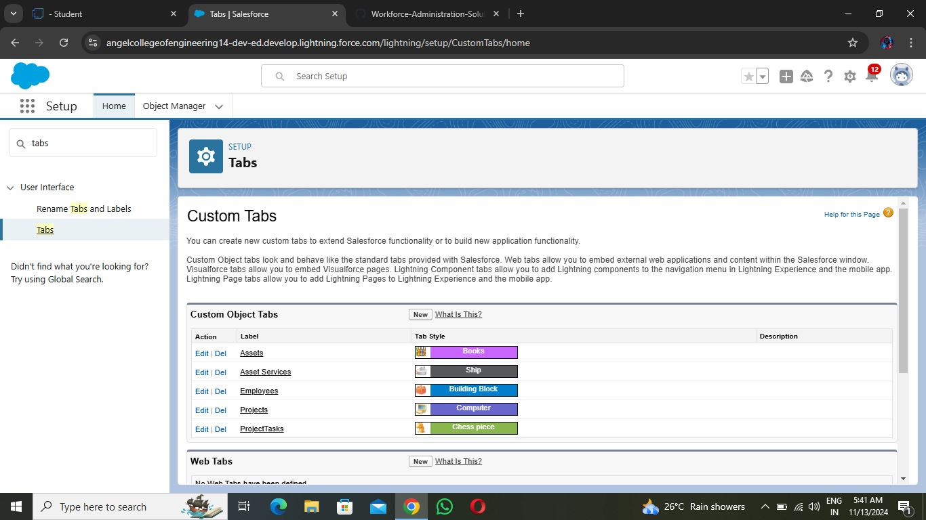

**Create a Lightning App**

1. Go to setup page **-->** search “app manager” in quick find **-->** select “app manager” **-->** click on **New lightning App.**
2. Fill the app name in app details and branding as follow  
   **App Name:** Workforce Administrator Solution  
   **Developer Name:** this will auto populated  
   **Description:** Give a meaningful description  
   **Image:** optional (if you want to give any image you can otherwise not mandatory)  
   **Primary color hex value:** keep this default
3. 3.     Then click Next **-->** (App option page) keep it as default **-->** Next **-->** (Utility Items) keep it as default **-->** Next.
4. **To Add Navigation Items:**

Search the items in the search bar (Employees, Projects, ProjectTask, Assets, Asset Services, Reports, Dashboard) from the search bar and move it using the arrow button **-->** Next

**Note:** select asset the custom object which we have created in the previous activity.

1. **To Add User Profiles:**

Search profiles (System administrator) in the search bar --> click on the arrow button --> save & finish.

**Creating Text Field in Employee Object**

1. Go to setup --> click on Object Manager --> type object name (Employee) in quick find bar --> click on the object.

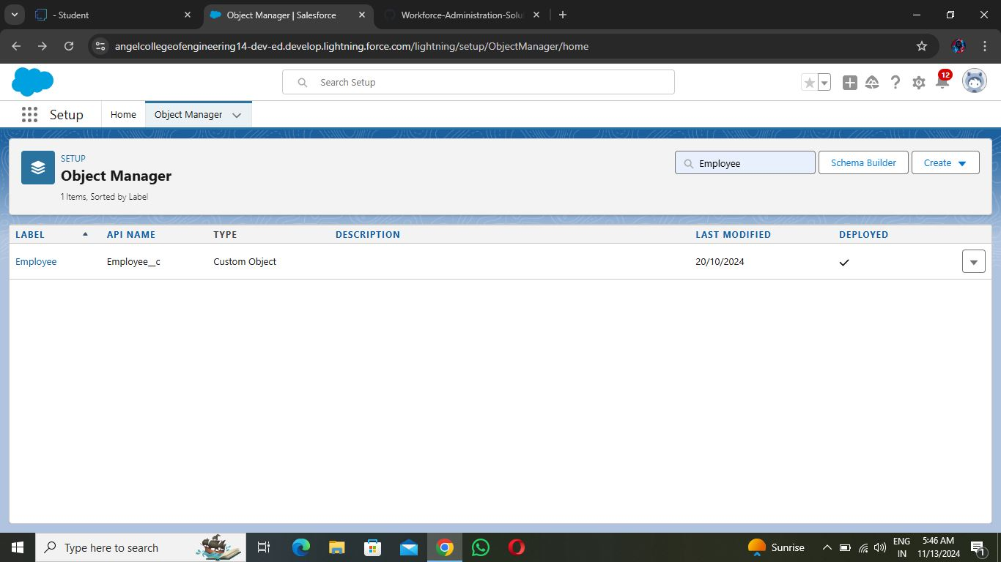

1. Now click on “Fields & Relationships” **-->** New
2. Select Data type as “Text”.
3. Click on Next.
4. Fill the above as following:
   1. **Field Label:** Employee Name
   2. **Length:** 18
   3. **Field Name:** gets auto generated
   4. Click on Next **-->** Next **-->** Save and new.

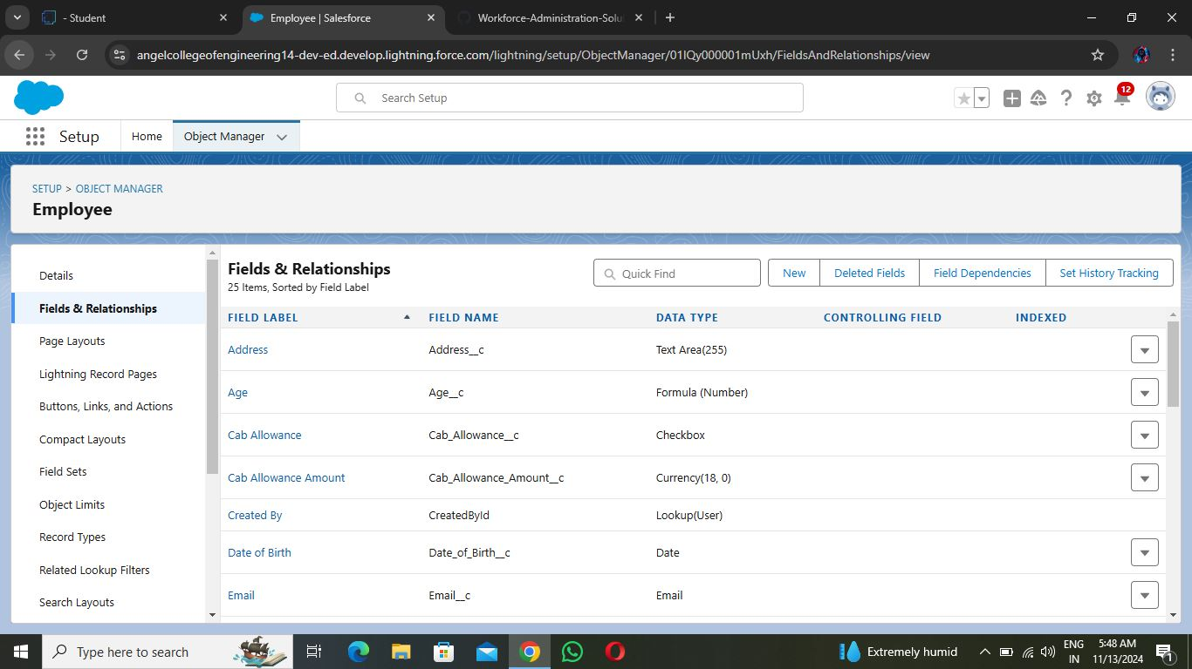

**Creating Date of Birth Field in Employee Object**

1. Repeat step 1 and 2 mentioned in activity 1
2. Select Data type as “**Date**” and click Next.
3. Click on Next.
4. Fill the above as following:
5. **Field Label:** Date of Birth.
6. **Field Name:** gets auto generated.
7. Click on Next **-->** Next **-->** Save and new.

**Creating Formula Field in Employee Object**

1. Repeat step 1 and 2 mentioned in activity 1
2. Select Data type as “Formula” and click Next.
3. Give Field Label and Field Name as “Age” and select formula return type as “Number” and click next.
4. Under Advanced Formula write down the formula and click “Check Syntax” and Next **-->** Next **-->** Save & New.

**Creating Picklist Field in Employee Object**

1. Repeat step 1 and 2 mentioned in activity 1
2. Select Data type as “Picklist” and click Next.
3. Enter Field Label as “Gender”, under values select “Enter values, with each value separated by a new line" and enter values as shown below.
4. Click Next --> Next --> Next --> Save & New.

**Creating Self-Relationship Field in Employee Object**

1. Repeat step 1 and 2 mentioned in activity 1
2. Select Data type as “Lookup Relationship” and click Next.
3. Select Employee from the drop down related to the field and click Next.
4. Give Field Label as “Reports to” and click Next.
5. Next --> Next --> Save & New.

**Creating Master-Detail Relationship between Employee & Asset Object**

1. Go to the setup page --> click on object manager --> type object name(ProjectTask) in the quick find bar --> click on the object.
2. Click on fields & relationship --> click on New.
3. Select “Master-Detail relationship” as data type and click Next.
4. For field label related to: select “Employee” object and click Next.
5. Give Field Label as “Employee Name” and click Next.
6. Next --> Next --> Save & New.

**Creating Remaining Fields in Employee Object**

|  |  |  |  |
| --- | --- | --- | --- |
| 1 | Employee | Field Name | Data type |
| 1          Qualification | Text |
| 2          Address | Text Area |
| 3          Experience | Text Area |
| 4          Phone no | Phone |
| 5          Email | Email |
| 6          Joining date | Date |
| 7          Mode of Work | Picklist: Values |
| On Site |
| Remote |
| 8          Cab Allowance | Check box |
| 9          Food Allowances | Check box |
| 10          Wifi Allowances | Check box |
| 11          Cab Allowance Amount | Currency |
| 12          Food Allowance Amount | Currency |
| 13          Wifi Allowance Amount | Currency |
| 14          Login Time | Time |
| 15          Logout Time | Time |
| 16          LinkedIn Profile | url |
|  | |
| 2 | Project | Field Name | Data type |
| 1      Project Name | Text |
| 2          Project Lead | Text |
| 3          Start Date | Date |
| 4          End Date | Date |
| 5          Project Status | Picklist: Values |
| Completed |
| On Going |
| Not Yet Started |
|  | |
| 3 | ProjectTask | Field Name | Data type |
| 1      Project Task | MDR with project object |
| 2          Finishes in | Formula : |
|  | (Project_Task__r.Start_Date__c  -  Project_Task__r.End_Date__c ) |
|  | Formula return type: Number |
|  | Numbers |
| 3          Working Hours | Master Detail relationship with Employee object |
| 4          Employee Name |  |
| Note: here in Finishes in field, Start Date and End Date belong to Employee Object. | |
|  | |
| 4 | Asset Service | Field Name | Data type |
| 1      Asset Id | Lookup relationship with Asset object |
| 2          Type | Picklist: Values |
| Technical Issue |
| Non Technical Issue |
| 3          Technician | Text |
| 4          Subject | Text Area |
| 5          Description | Text Long |
|  | |
| 5 | Asset | Field Name | Data type |
| 1          Asset Type | Picklist: Values |
| Laptop |
| Charger |
| Mouse |
| Monitor |
| CPU |
| 2      Model Name | Text |
| 3          Employee Name | Lookup relationship with Employee Object |
| 4          Date Of Issue | Formula ( Joining date) |
| Formula Return type: date |
| Note: here in the Date of Issue field, the Joining date field belongs to the Employee Object. | |

**Create OWD Setting**

1. Go to Set Up **-->** in the Quick Find box type "Sharing Settings" **-->** click on it.
2. Click Edit in the Organization-Wide Defaults area.
3. Search for the Employee object.
4. Under default internal access and default external access change the options to “Private” and under grant access using hierarchies select the check box.
5. Click on save.
6. This Setting is for all the Users Which have been Created.
7. Set OWD as Private for Project and Asset Service objects.

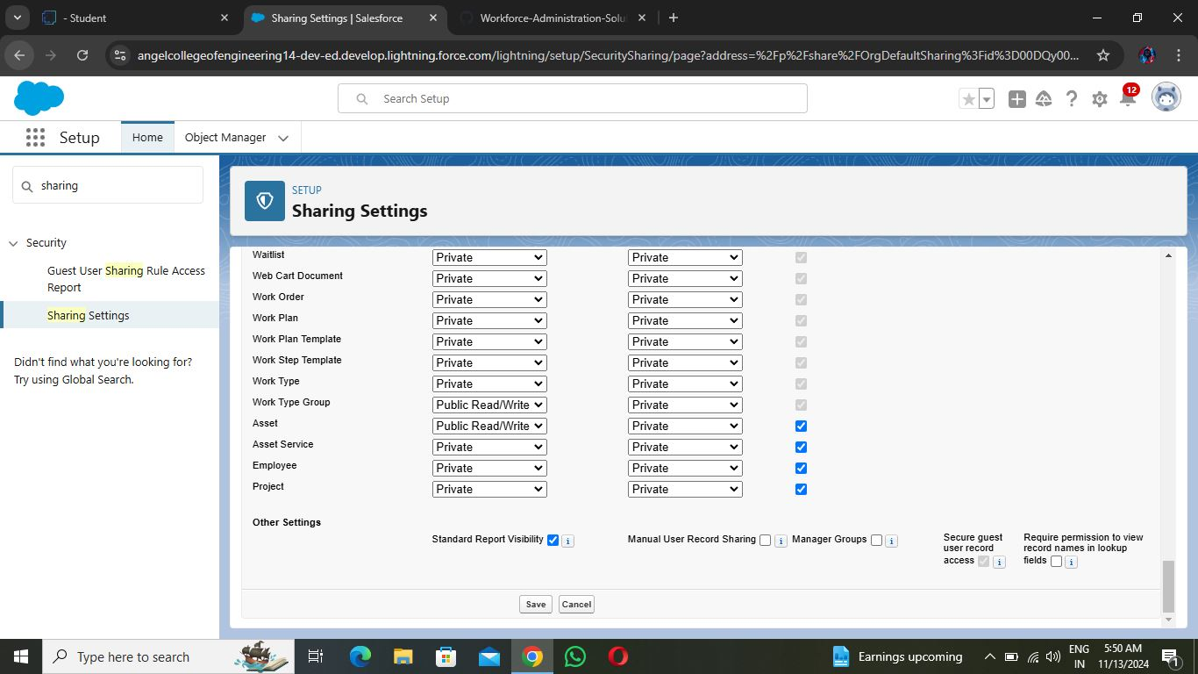

**Create a Record (Employee)**

1. Click on App Launcher on the left side of the screen.
2. Search Employee Management System & click on it.
3. Click on the Employee tab.
4. Click New.
5. Fill the Details and click on Save.

**View a Record (Employee)**

1. Click on App Launcher on the left side of the screen.
2. Search Employee Management System & click on it.
3. Click on the Employee Tab.
4. Click on any record name. you can see the details of the Employee.

**Delete a Record (Employee)**

1. Click on App Launcher on the left side of the screen.
2. Search Employee Management System & click on it.
3. Click on the Employee Tab.
4. Click on Arrow at right hand side on that Particular record.
5. Click delete.

**Importing data using Data Wizard**

1. From Setup, click the Home tab.

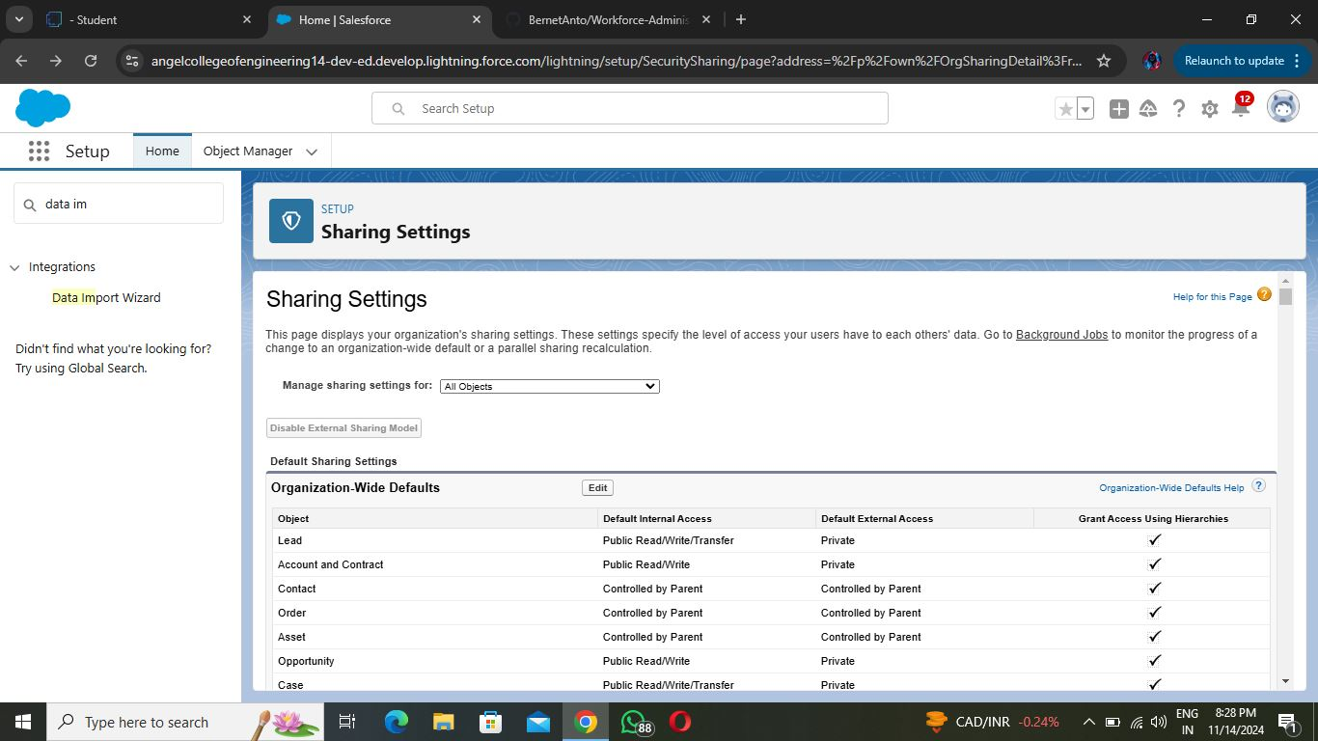

1. In the Quick Find box, enter Data Import and select Data Import Wizard.
2. Click Launch Wizard!

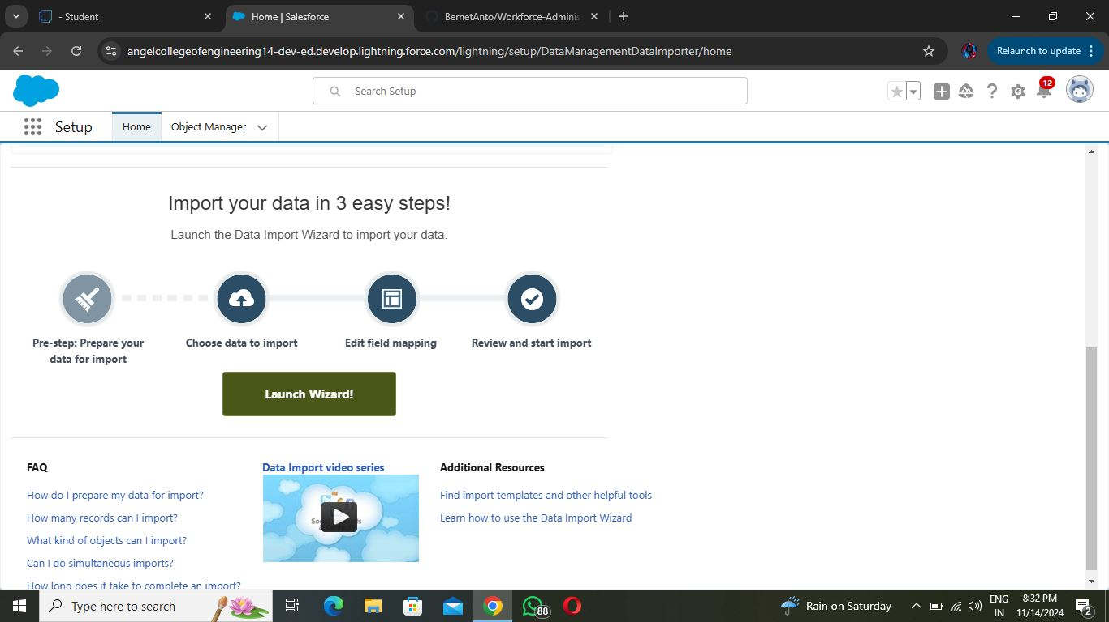

1. Click the Custom Objects tab and select the Employee object.
2. Select Add new records.

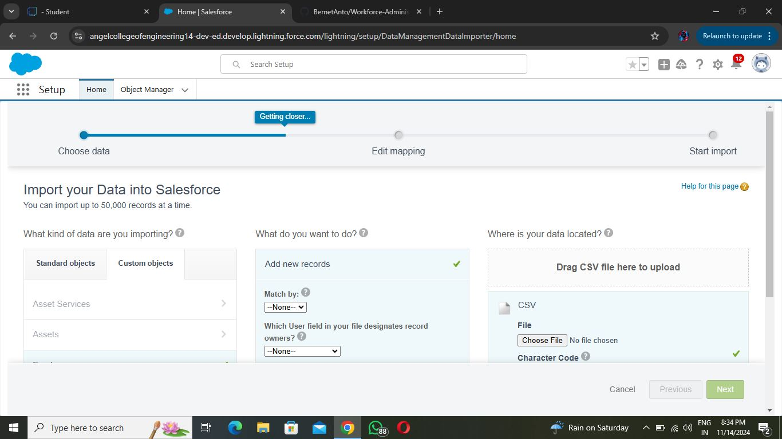

1. Click CSV and choose file Employee_CSV which we made earlier. Click Next.
2. Since the field names in the CSV file (CSV Header) are the same as the field names in your object (Mapped Salesforce Object), the fields are automatically mapped. Click Next.

Note: no need to map “Reports to” field. The Data Import Wizard is designed to handle basic data import tasks and does not support mapping relationships between records.

1. The next screen gives you a summary of your data import. Click Start Import.
2. Click OK on the popup.
3. Scroll down the page and verify that your data has been imported under batches.

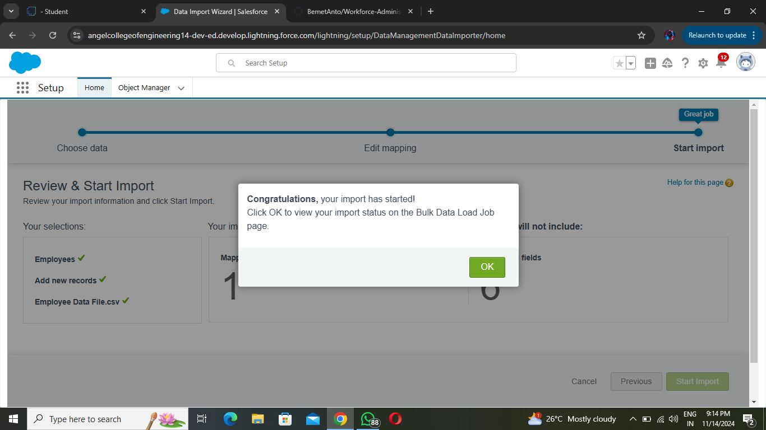

**HR Profile**

1. Go to setup **-->** type profiles in quick find box **-->** click on profiles **-->** clone the desired profile (Standard user) **-->** enter profile name (HR) **-->** Save.

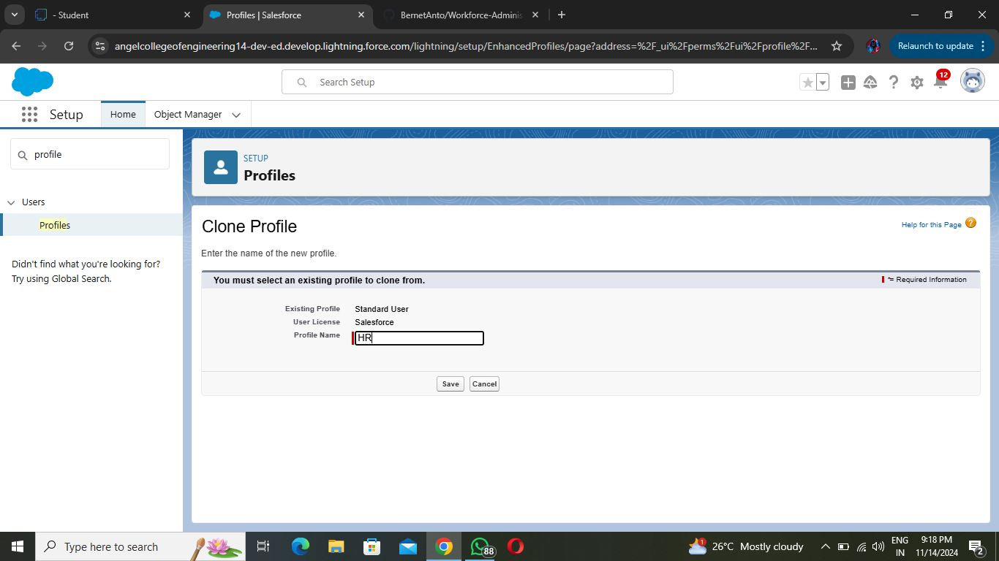

1. While still on the profile page, then click Edit.
2. Scroll down to Custom Object Permissions and Give access permissions for Assets and Asset Services objects.

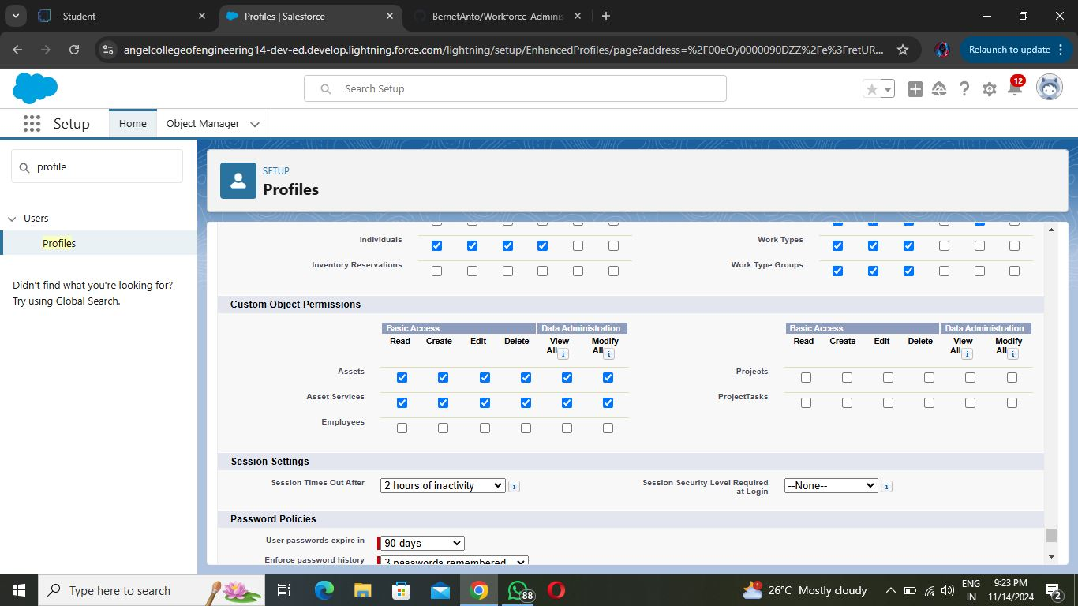

1. Scroll down and Click on Save.

**Manager Profile**

1. Go to setup --> type profiles in quick find box --> click on profiles --> clone the desired profile (Salesforce Platform User) --> enter profile name (Manager) --> Save.
2. While still on the profile page, then click Edit.
3. Scroll down to Custom Object Permissions and Give access permissions for Employee, Project and Project Task objects.
4. Scroll down and Click on Save.

**Create Employee Profile**

Create Employee Profiles for “On Site Employee”, “Remote Employee” as in Activity 2, but in step 3 only allow permission access for Project and Project Task objects only.

**Creating HR Role**

1. Go to quick find **-->** Search for Roles **-->** click on set up roles.

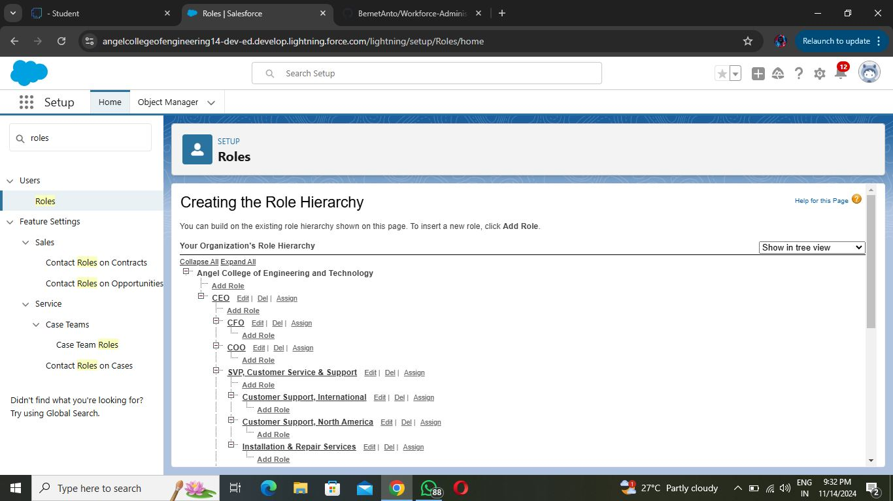

1. Click on Expand All and click on add role under whom this role works.

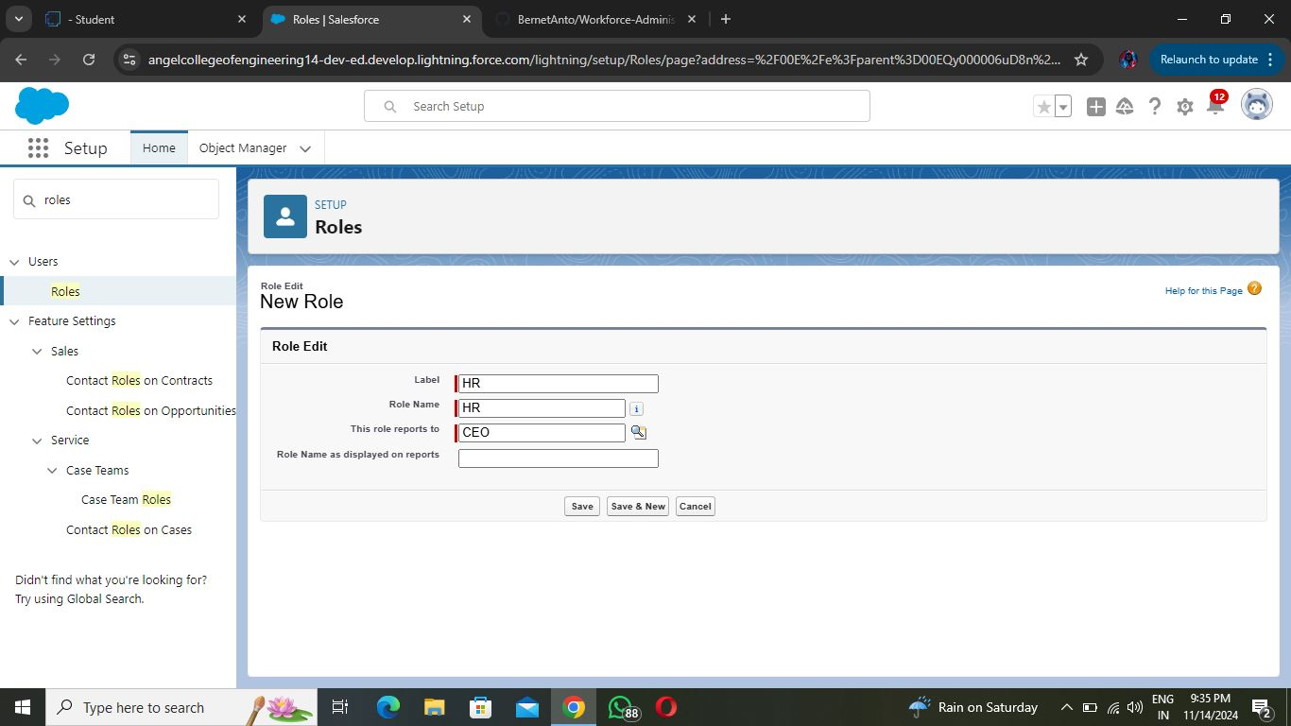

1. Give Label as “HR” and Role name gets auto populated. Check to whom this role (HR) reports. Then click on Save.
2. Refer the below diagram to understand which role reports to which role.

**Creating more roles**

Create three more roles for Manager, On Site Employee, Remote Employee.

Note: On Site Employee and Remote Employee reports to Manager.

**Create User**

Go to setup --> type users in quick find box --> select users --> click New user.

Fill in the fields

1. **First Name   :** Niklaus
2. **Last Name    :** Mikaelson
3. **Alias              :** Give a Alias Name
4. **Email id        :** Give your Personal Email id
5. **Username    :** Username should be in this form: text@text.text
6. **Nick Name   :** Give a Nickname
7. **Role              :** HR
8. **User license :** Salesforce
9. **Profiles        :** HR

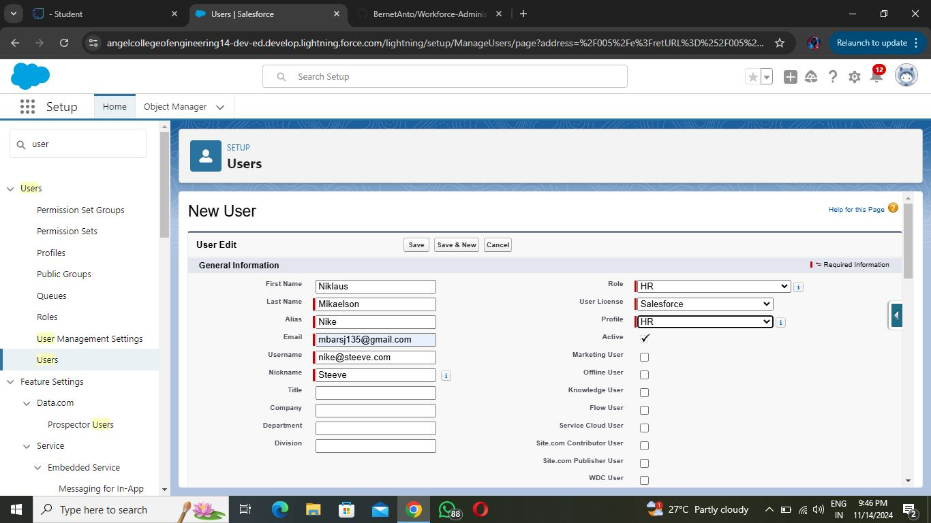

Save.

**Creating another user**

Go to setup --> type users in quick find box --> select users --> click New user.

Fill in the fields

1. **First Name    :** Kol
2. **Last Name    :** Mikaelson
3. **Alias              :** Give a Alias Name
4. **Email id        :** Give your Personal Email id
5. **Username      :** Username should be in this form: text@text.text
6. **Nick Name    :** Give a Nickname
7. **Role              :** Manager
8. **User license   :** Salesforce Platform
9. **Profiles          :** Manager

Save.

**Creating more users**

Create two more users as we created in activity 2.

**Creating a page layout for Employee object**

1. Go to Setup **-->** Click on Object Manager **-->** Search for the object (Employee) **-->** From drop down click on Edit.

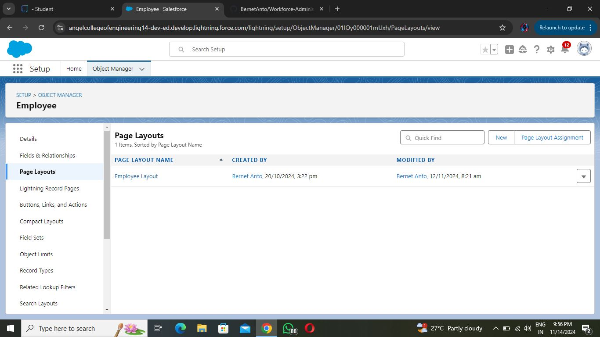

1. Click on Page layout --> Click on New.
2. Give Page layout Name as “On Site Employee Layout” and click on Save.

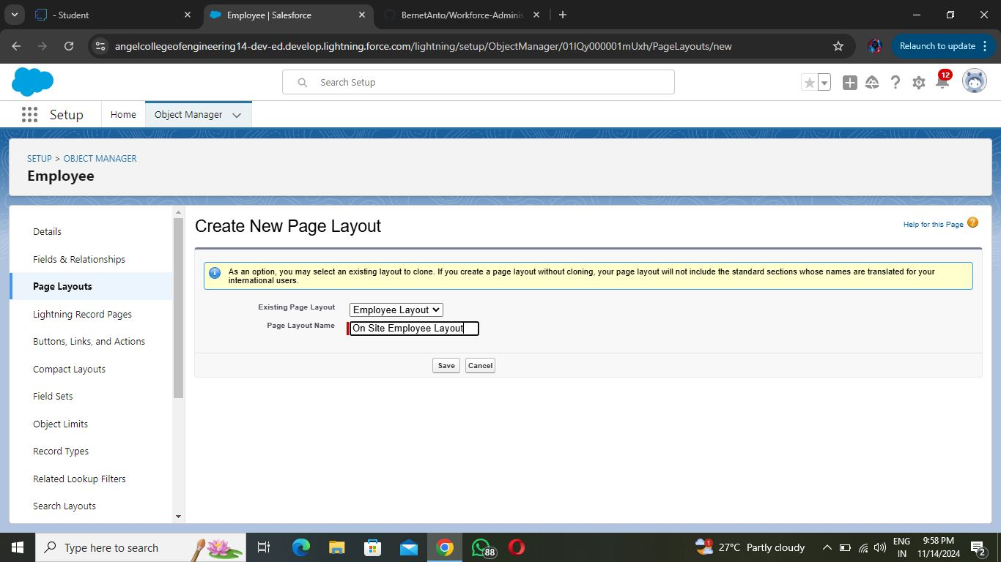

1. Drag and drop the Section from the highlight panel below the Information and name it as “Personal Information” and click Ok.
2. Drag Date of Birth, Address and Age fields from Employee Information to Personal Information section.

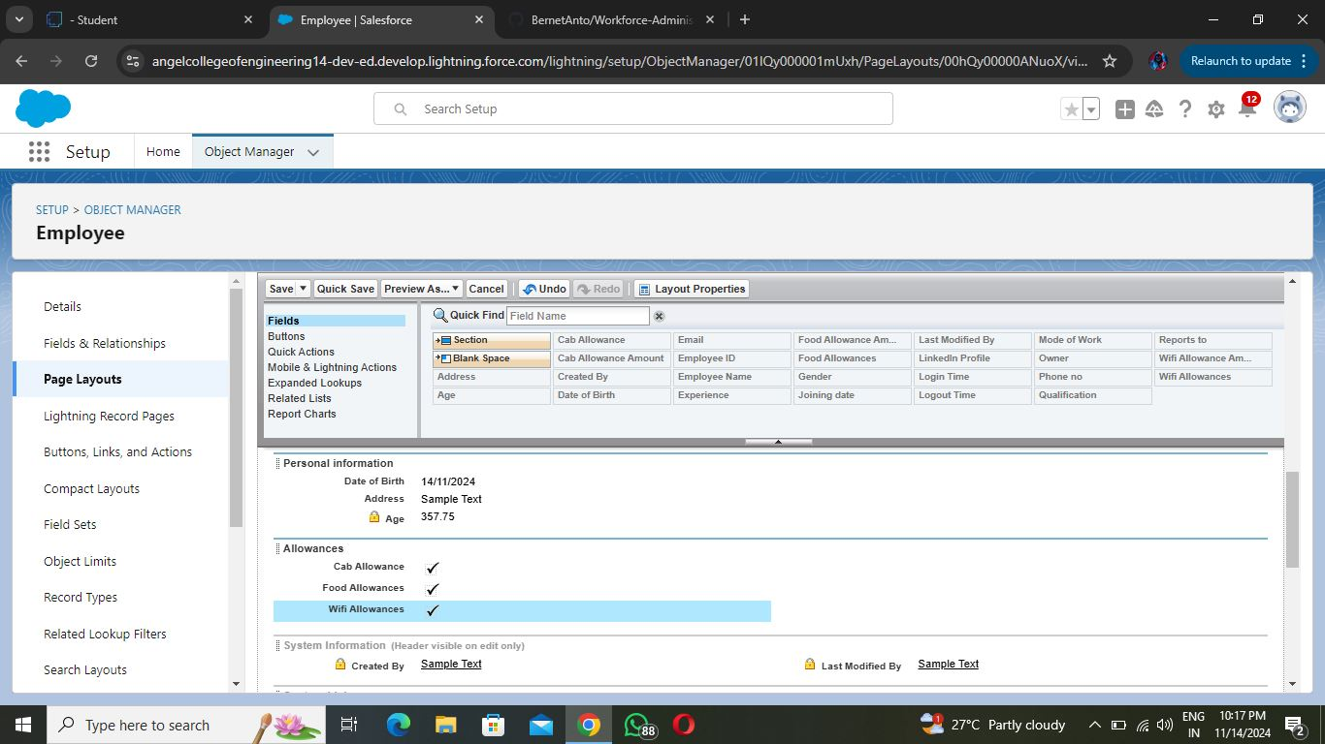

1. Similarly perform the above step to create “Allowances” and add allowances fields in it as shown below.
2. Click Save.

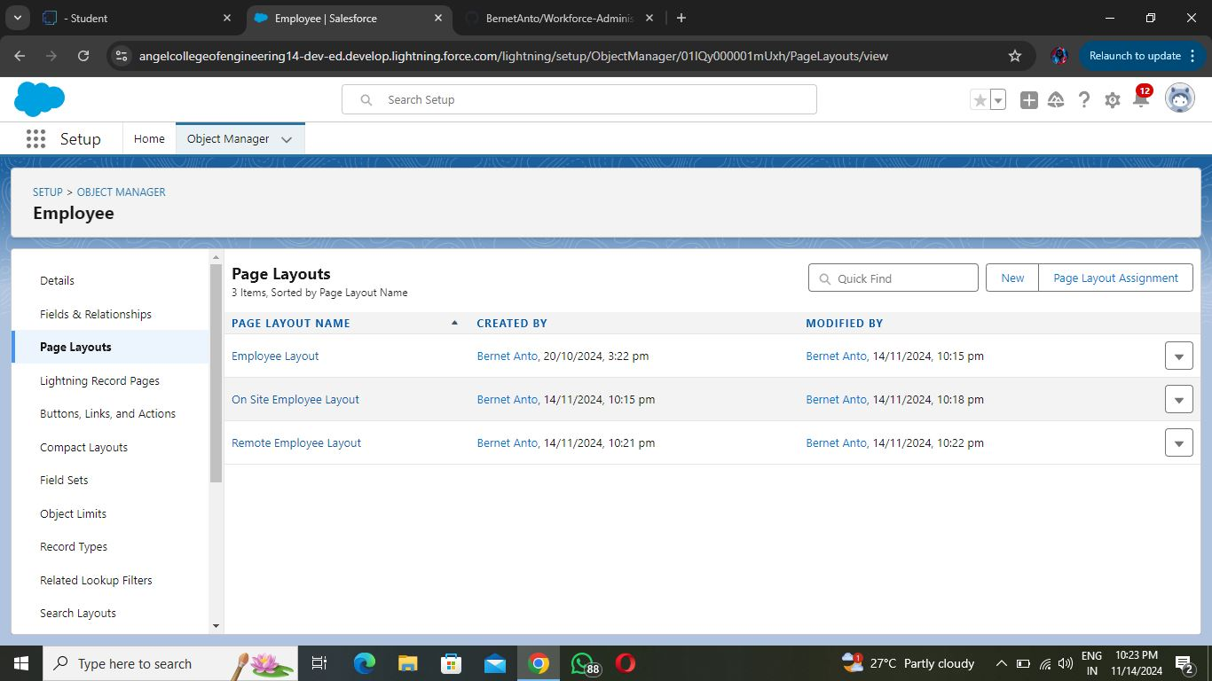

**Creating another page layout**

Create another page layout and name it as “Remote Employee Layout”,  and in the allowances section use only Wi-Fi Allowance and Wi-Fi Allowances Amount fields.

**Creating a chatter group for your organization.**

1. Click the App Launcher.
2. Enter Groups in the Search apps and items... box and select Groups.
3. Click New.
4. Fill in the new group information with these details:

|  |  |
| --- | --- |
| Field | Value |
| 1      Group Name  2      Description  3      Access Type  4      Allow Customers | Internal Discussion  Give a understanding Description on your own  Private  Checked |

1. Click Save & Next. Skip the Upload Picture section and click Next.

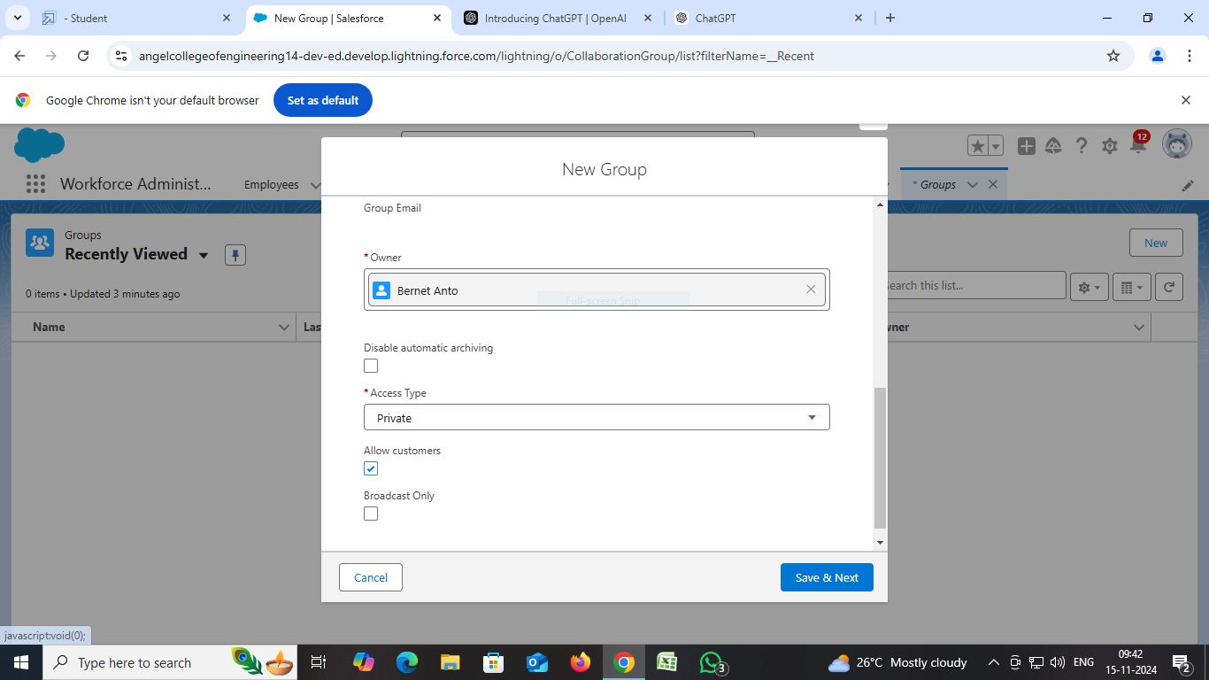

1. On the Manage Members screen, click Add next to users you created in the previous activity.
2. Click Done.
3. This is how your group interface looks like.
4. Where it says Share an update, post this message to the group: Welcome to the Internal Discussion Group, here you can post anything which is related to ongoing projects.
5. Click Share.

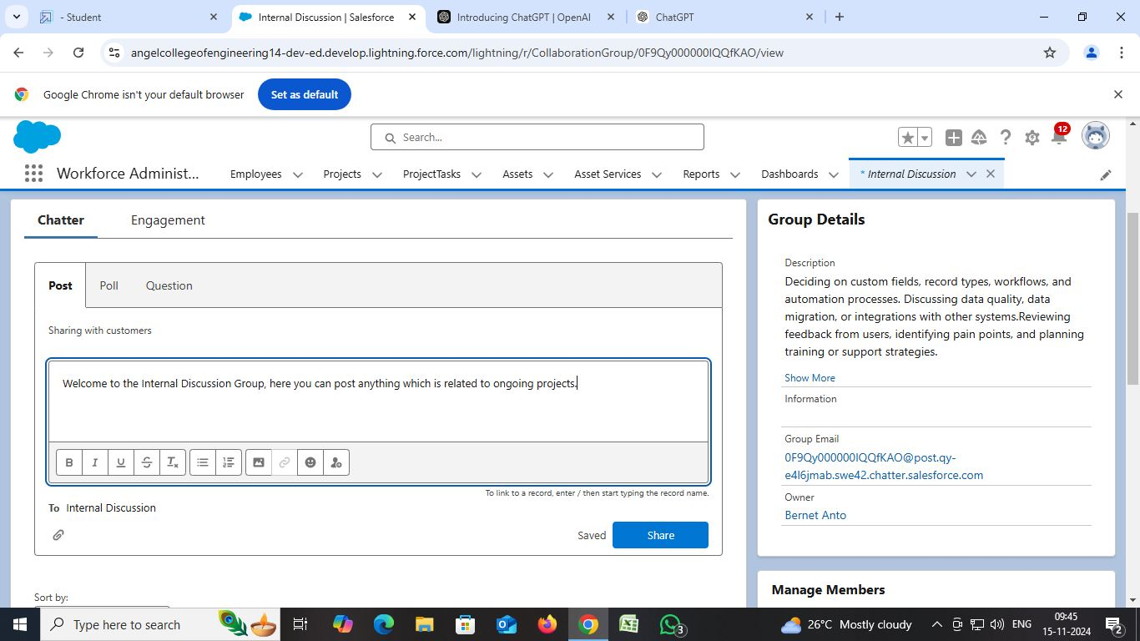

Note: You can like or comment on this post.

Note: there is a default chatter group in the org with all the active users in it, this activity is to show you how to create a chatter group and add users into it.

**Creating On Site Employee Record Type**

1. Go to Setup --> click on Object Manager --> Search for the object (Employee) --> from drop down click Edit.
2. From the left panel click Record Types --> New.
3. Give Record Type Label as “On Site Employee” and make it active.

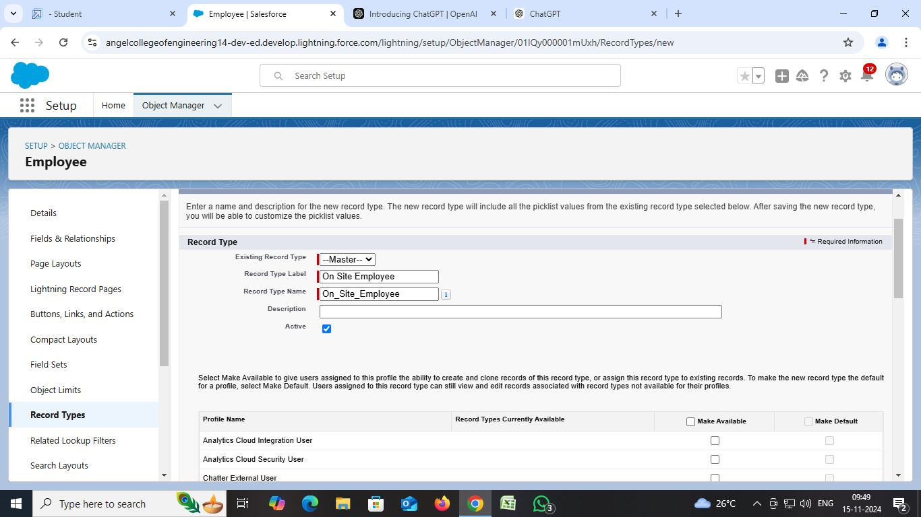

1. Uncheck for “Make Available”.
2. Scroll down and check for the Manager & System Administrator profile and click on Next.
3. Select “Apply a different layout for each profile”, and change page layout to On Site Employee Layout for manager profile and System Administrator.
4. click Save.

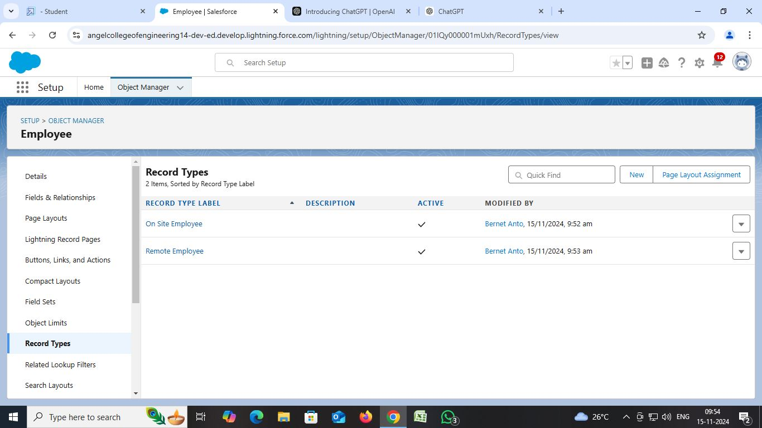

**Creating "Remote Employee" Record Type**

Create another Record Type with name “Remote Employee” following the step from activity 1.

Note: use Remote Employee page layout for Remote Employee record type.

**Creating a permission set**

1. Go to setup --> type “permission sets” in quick search --> select permission sets --> New.
2. Enter the label name as “Per to Emp” --> Save.

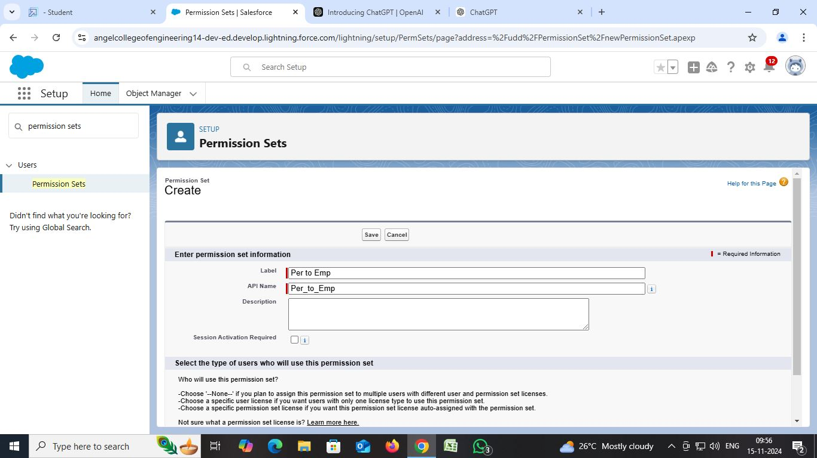

1. Under Apps Select object settings.
2. Click on Employee object --> click on Edit --> under object permission check for read and create.

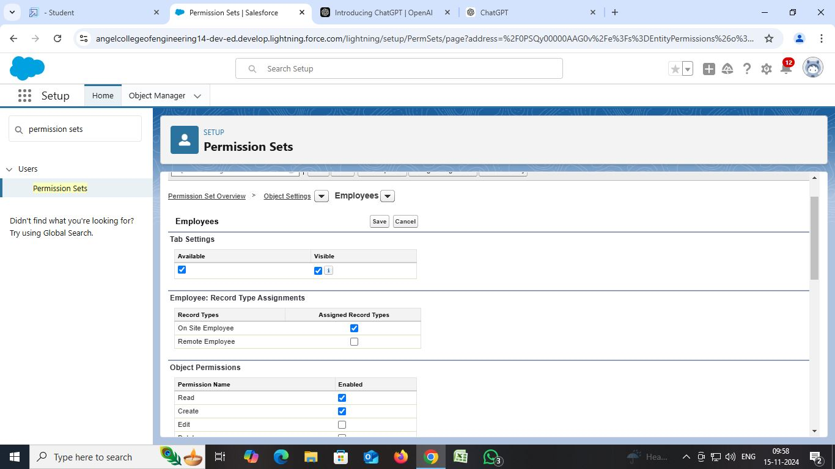

1. Click on Save.
2. After saving the permission click on the Manage assignment
3. Now click on the Manage Assignment.
4. Click on Add Assignment.

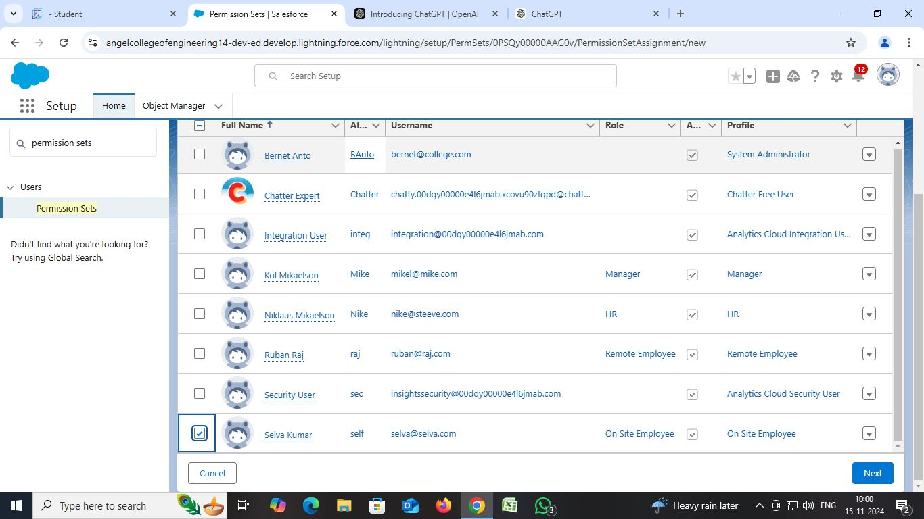

1. Now select the users (any one user with the profile “On Site Employee”) and click on Next.
2. Click on Assign

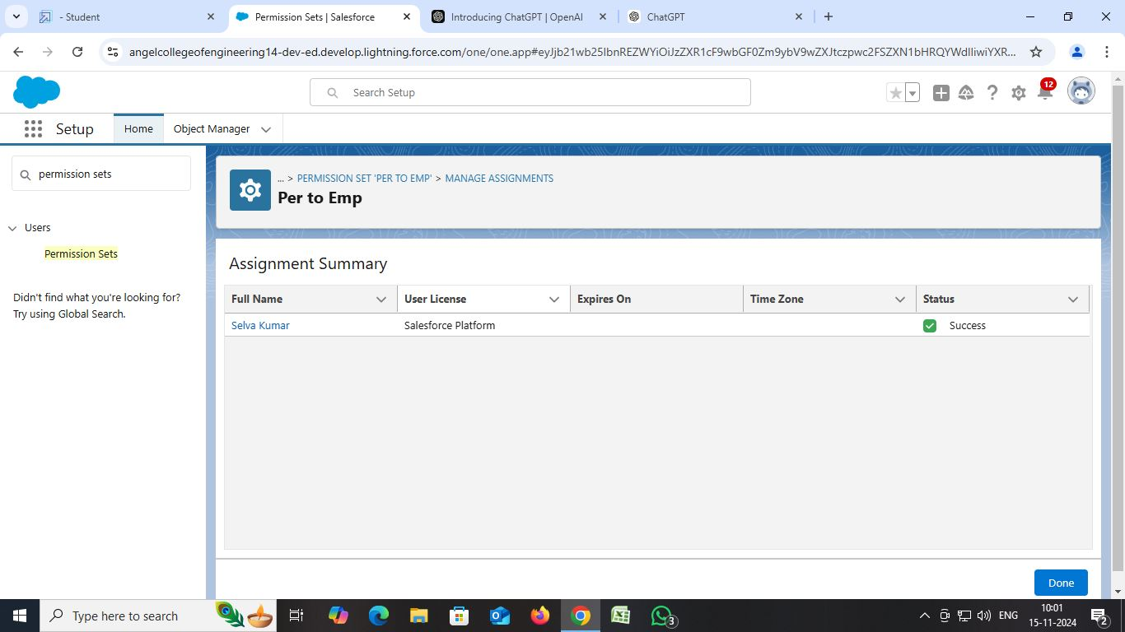

1. Click on Done.

**Create Report**

1. Go to the app --> click on the reports tab
2. Click New Report.
3. Select report type from category or from report type panel or from search panel --> click on start report.

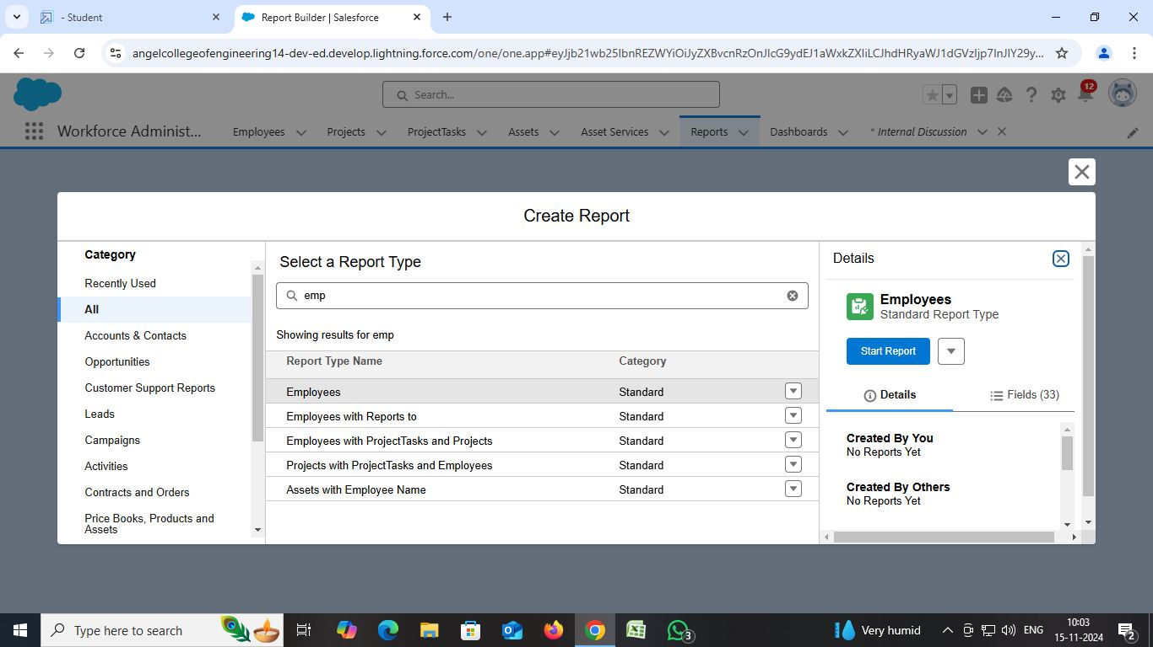

1. Customize your report --> Add fields from left pane as shown below

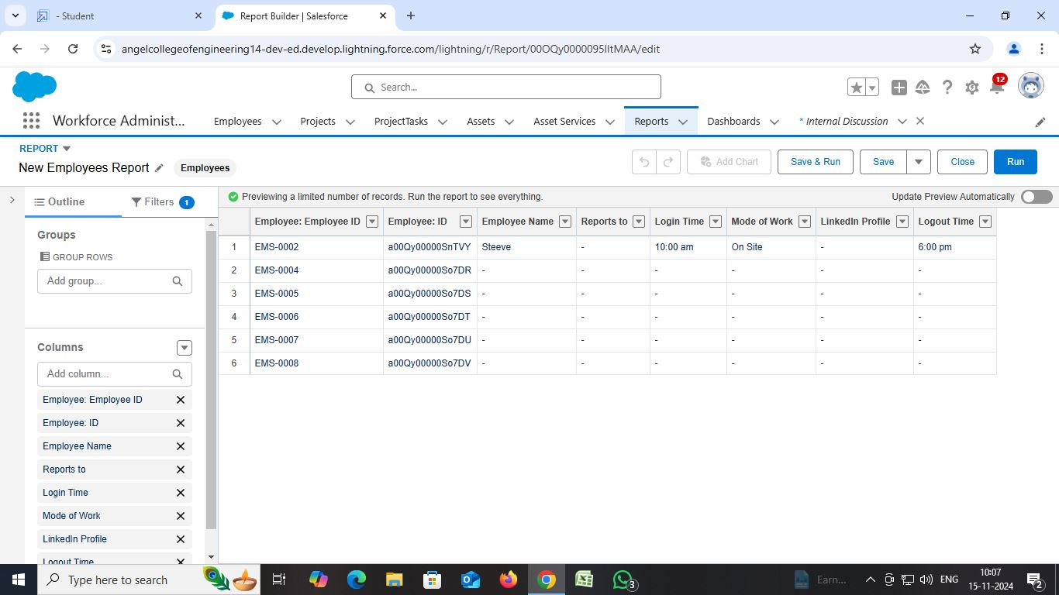

1. Save or run it.

 Note: Reports may get varied from the above pictures as the data might be different.

**Create 2 more Report**

1. Create a report with report type: “Employees with ProjectTasks and Projects”.
2. Create a report with report type: “Employees with Assets”.

**Create Dashboard**

1. Go to the app --> click on the Dashboards tabs.
2. Give a Name and click on Create.

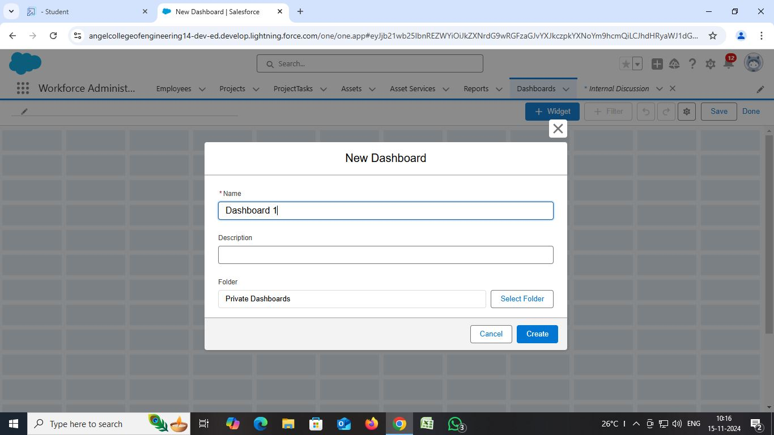

1. Select add component.
2. Select a Report and click on select.
3. Click Add then click on Save and then click on Done.

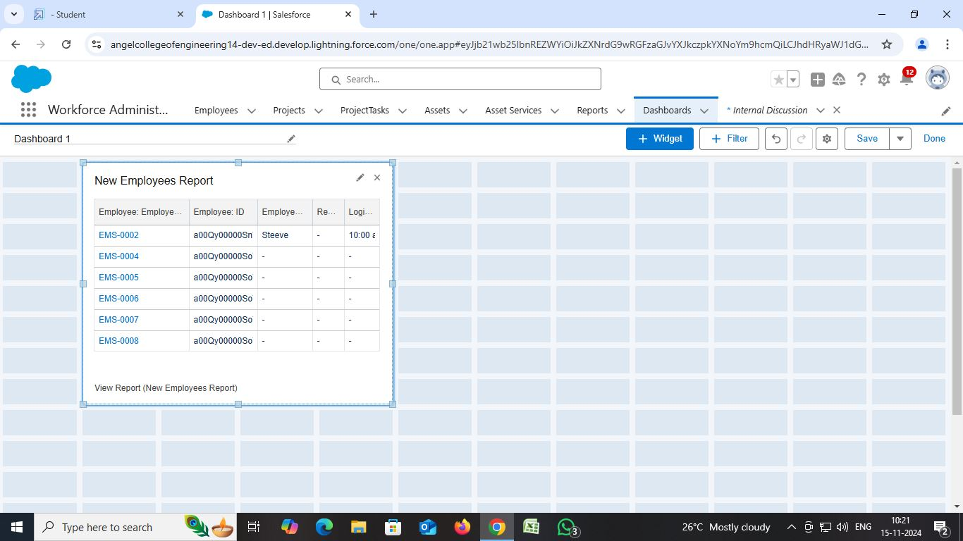

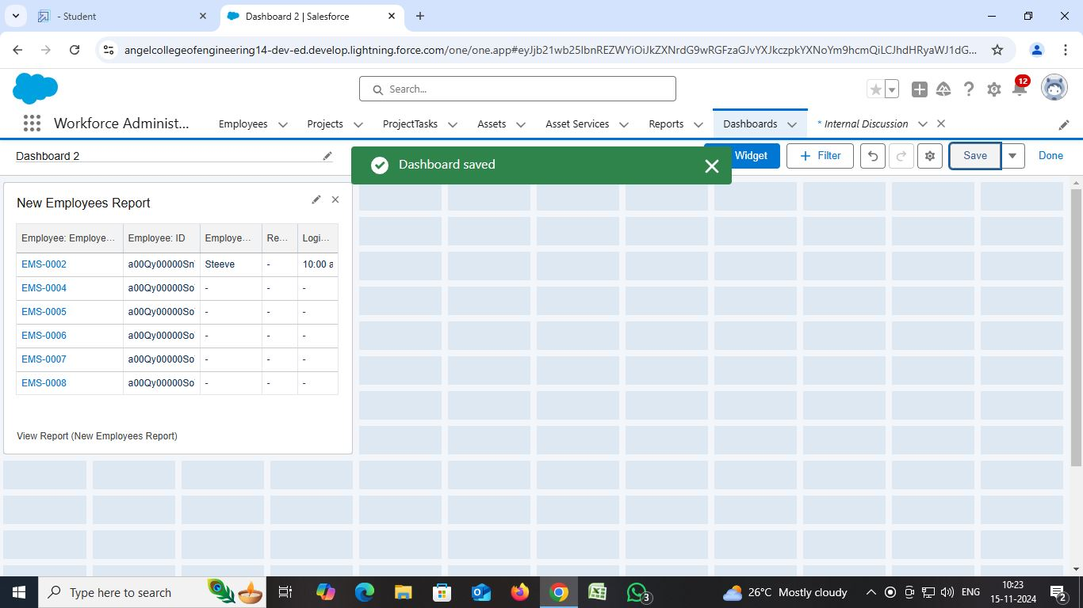

**Approval Process**

Create the leave object with the following fields.

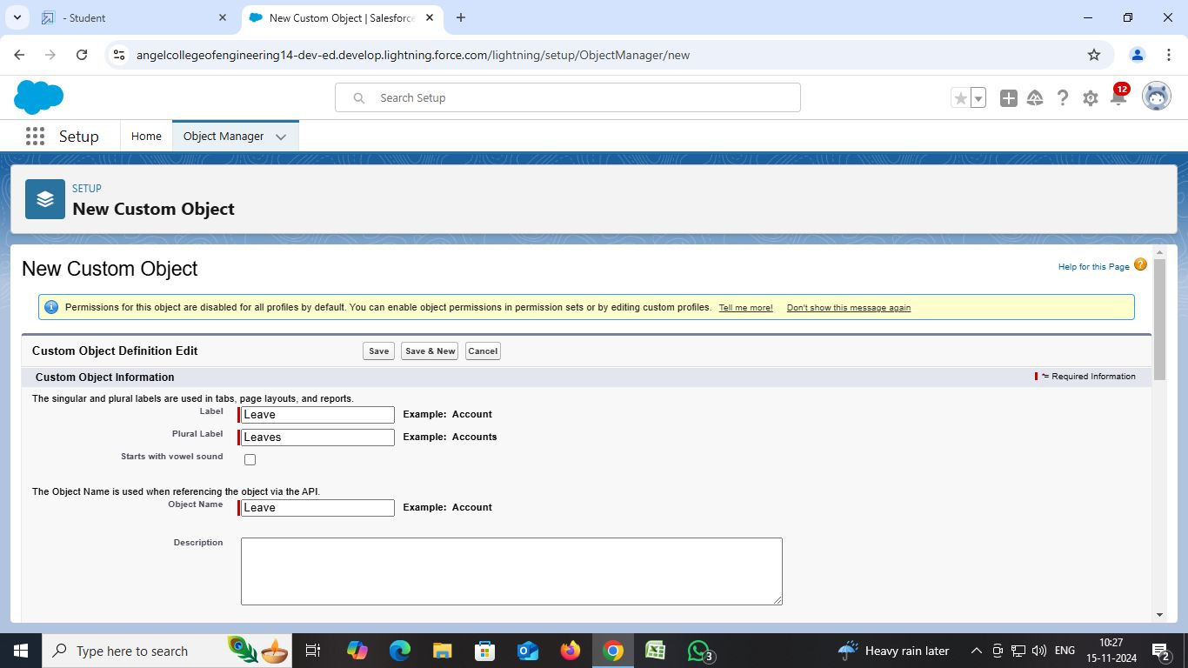

|  |  |  |
| --- | --- | --- |
| Object | Fields | Datatype |
| Leave | Employee Name  No. of Days  Subject  Description Status | Lookup with Employee object  Number  Text  Text Area (Rich)  Picklist: values as follows   |  | | --- | | Submitted  Approved  Rejected |   Note: Make sure the Status field is read only for everyone. (Give read only permission in step 3 while creating the field) |

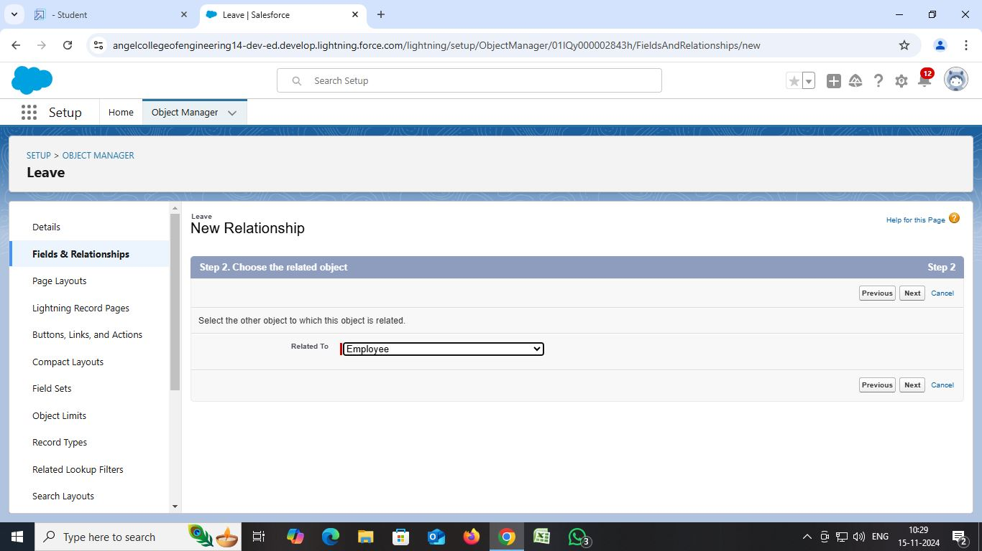

**Create an Approval Process for Leave object**

1. Go to Setup --> type Approval Processes in quick find --> click on Approval Processes.  
   In the Manage Approval Processes For list, select Leave.

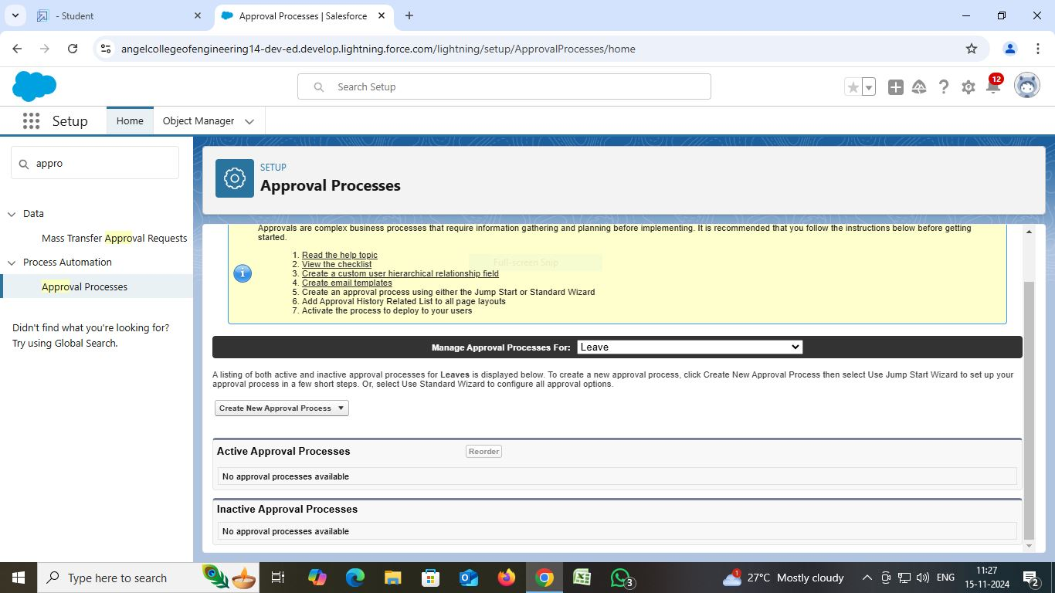

1. Click Create New Approval Process and select Use Jump Start Wizard.  
   Enter the following parameters

|  |  |
| --- | --- |
| Parameter | Value |
| Name | Leave Approval Request |
| Unique Name | Leave_Approval_Request (This automatically gets sent when you tab out of the Name field) |
| Approval Assignment Email Template | Leave blank |
| Add the Submit for Approval button and Approval History related list to all Travel Approval page layouts | Leave this selected/checked |
| Use Approver Field of Leave Owner | Leave unselected/unchecked. |
| Select Approver | select Automatically assign to approver(s) and for users select the name of the user with the Manager role. |

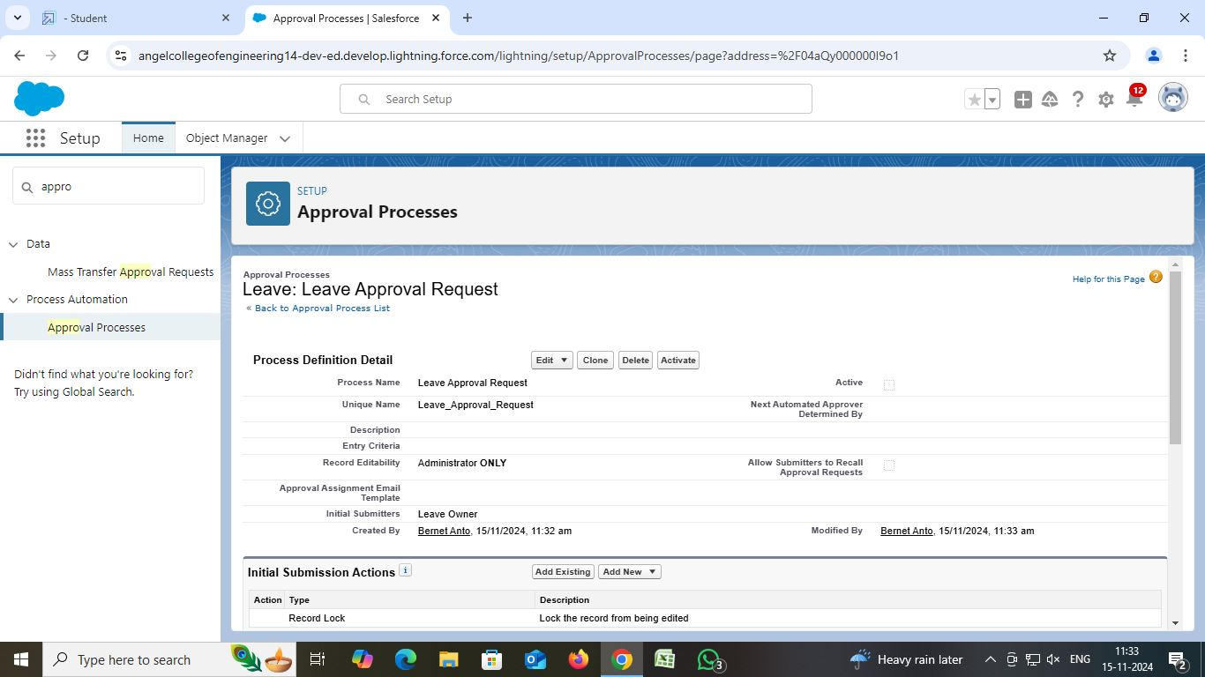

1. Click Save.
2. Click View Approval Process Detail Page.

**Initial Submission Action:**

1. Under initial submission action click on add new and then select field update.
2. Give name as “Approval Status to Submitted”.
3. Select Status for the field to update.
4. Under specify new field value select “A specific value” and select submitted and click Save.

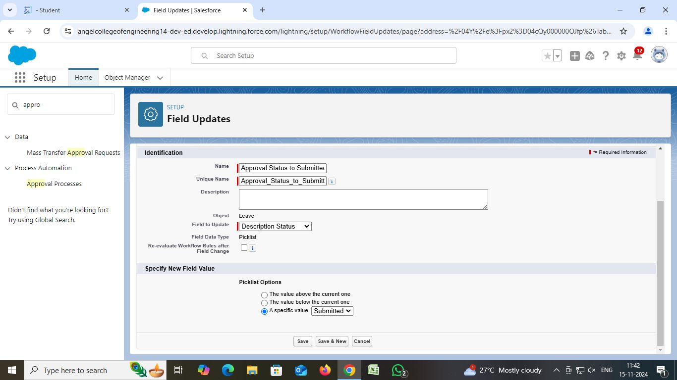

**Approval Steps:**

1. While you are still on Leave Approval Request detail page,
2. Under approval steps click the new approval step.
3. Give the name as “Approval from HR” and click on next.

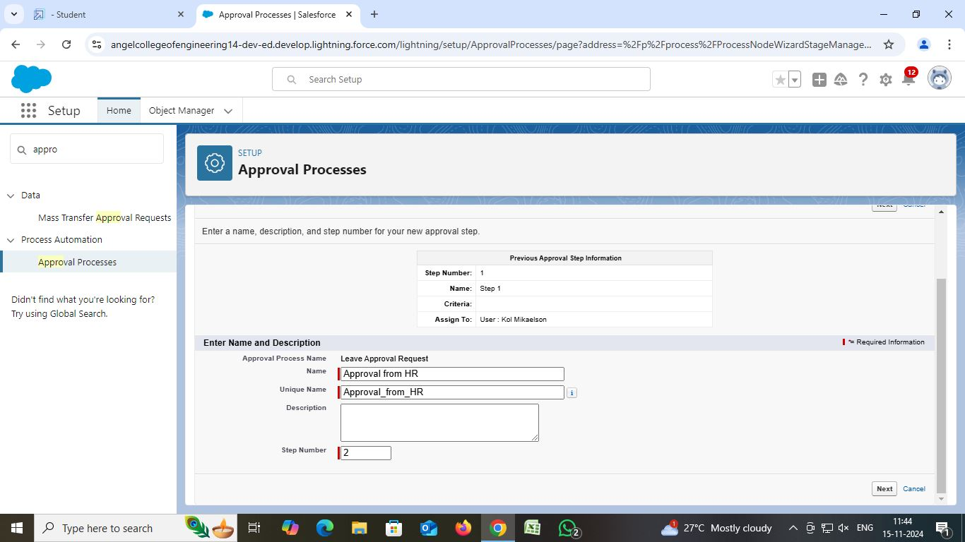

1. Under specify step criteria select “Enter this step if the following (Criteria are met)”,  
   Select field: “Leave: No. of Days”,  
   Operator: equals  
   Value: 5

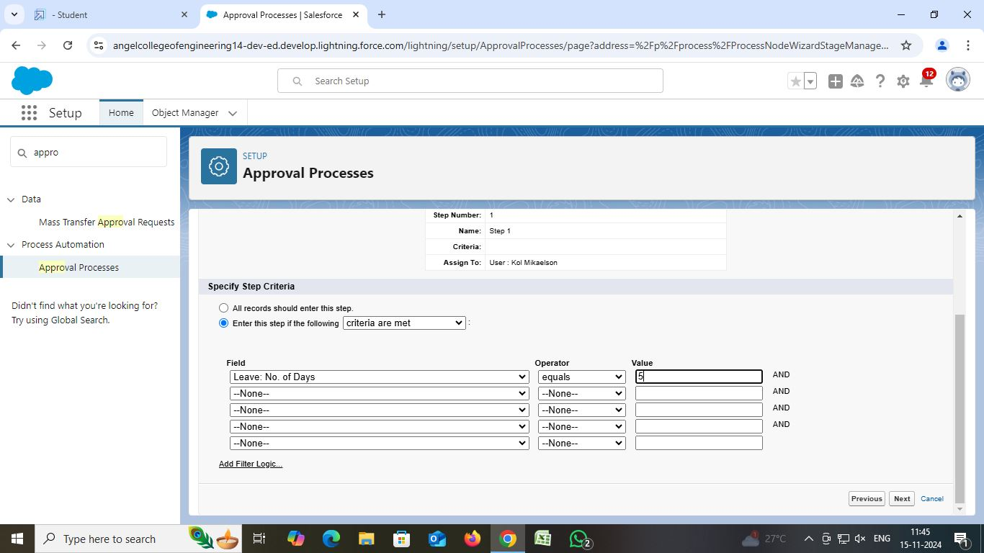

1. Click next.
2. Under select approver: select Automatically assign to approver(s) and for users select the name of the user with the HR role.
3. Click on Save.
4. No, I'll do this later. Take me to the approval process detail page to review what I've just created and click Go.

**Final Approval Action**

1. Under initial submission action click on add new and then select field update.
2. Give name as “Approval Status to Approved”.  
   Select Status for the field to update.

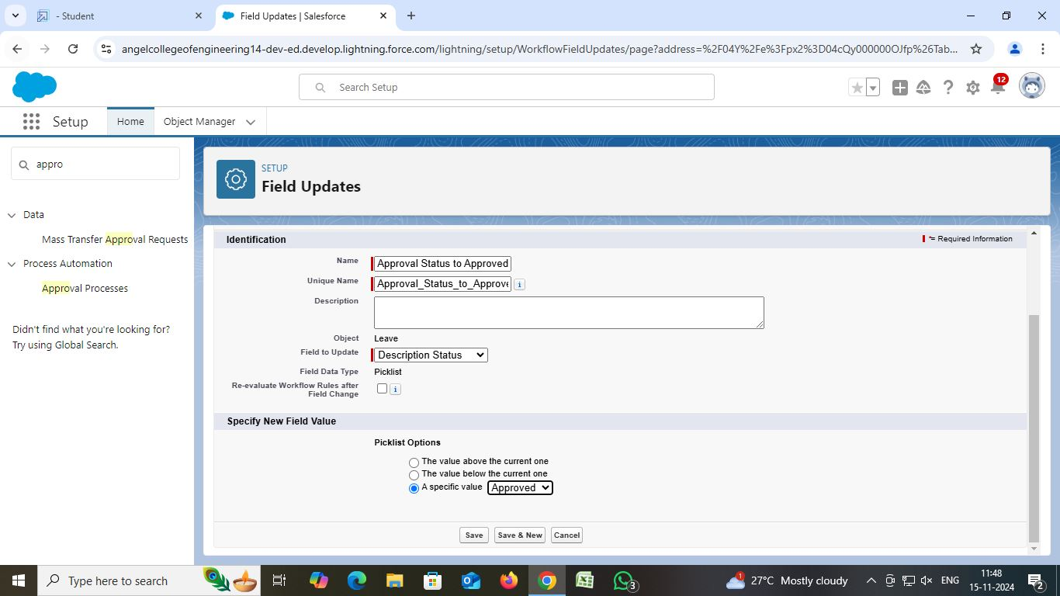  
Under specify new field value select “A specific value” and select Approved and click Save.

**Final Rejection Action**

1. Under initial submission action click on add new and then select field update.
2. Give name as “Approval Status to Rejected”.
3. Select Status for the field to update.

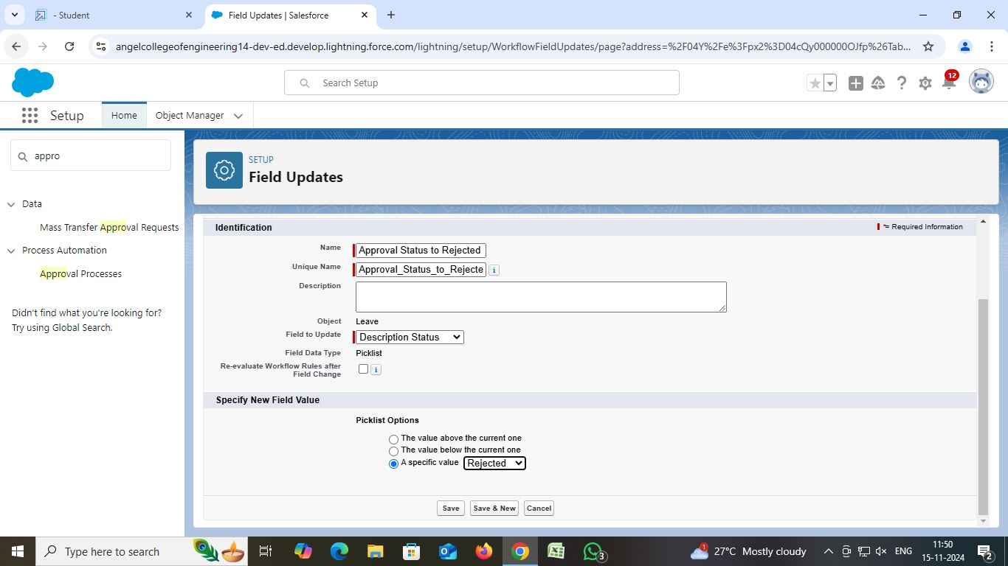

1. Under specify new field value select “A specific value” and select Rejected and click Save.

**Create an Apex Trigger**

1. Click on the file --> New --> Apex Class.

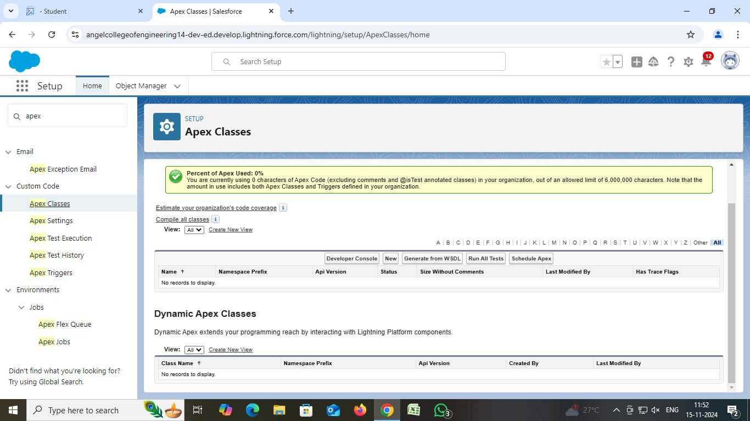

1. Give the Apex Trigger name as “EmpInsert”, and select “Employee__c” from the dropdown for sObject.  
   Click Submit.

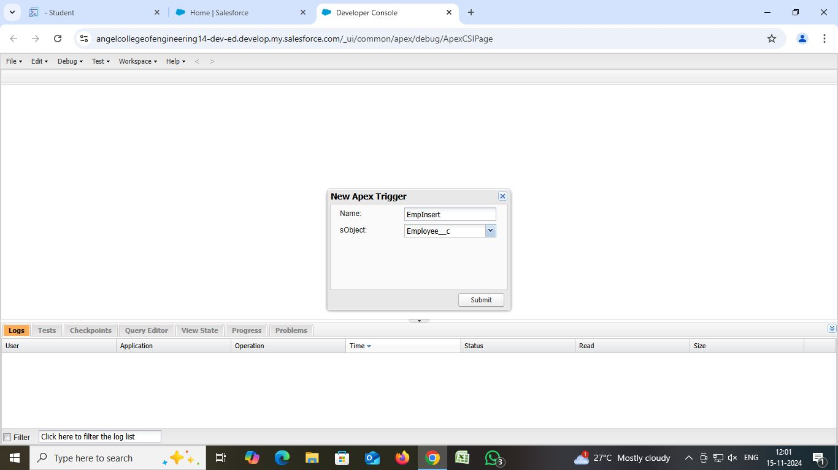

1. Now write the code logic here

Code Snippet:  
trigger EmpInsert on Employee__c (before insert) {

for(Employee__c pass : Trigger.New){

List<Employee__c> mynew = [SELECT Id, Name FROM Employee__c WHERE Employee_Name__c =: pass.Employee_Name__c];

if(mynew.size() > 0){

         pass.Name.addError('Employee with same name is existing');

      }

    }  
}

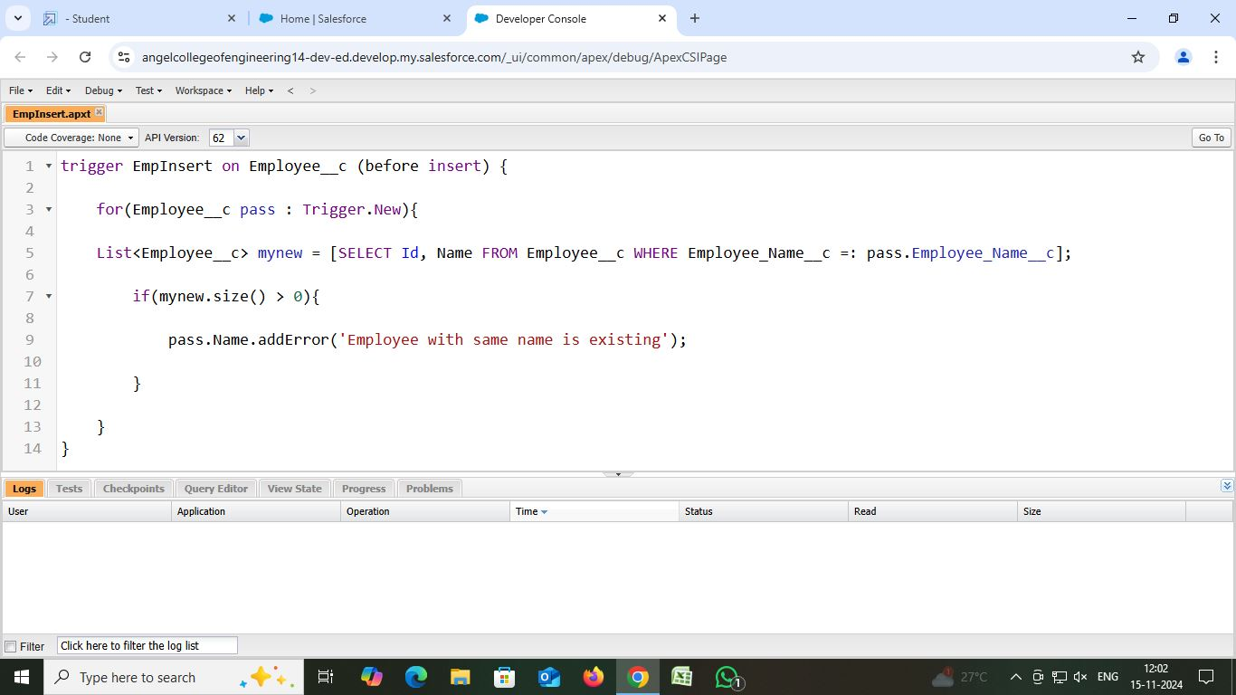

Save the code. (click on file --> Save)